 | MARCH NEWSLETTER 2022  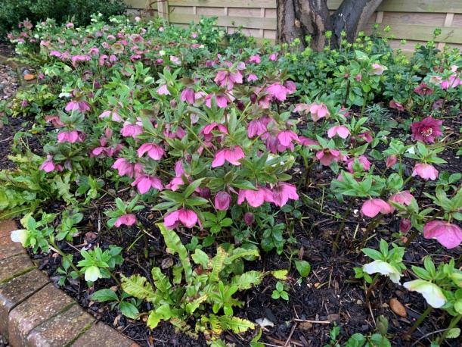  Spring hellebores
Dear Member,
After an extraordinary two years it does feel rather strange to be contemplating a full summer programme. As I write we are just coming to the end of 3 named storms in one week with wind and rain battering the garden. The plants seem to have been pretty resilient, apart from early crocus, and on sunny days the bumble bees are out foraging, the birds are getting ready to nest and the daffodils and other spring plants are preparing their show.
MEETINGS finally began again in October and have been well attended. We have three meetings left before the summer. This month Geoff Hodge will talk about gardening in dry and drought conditions. In April Barry Gayton will talk about dealing with pests and diseases inside and out – he should know as he has over 13,000 cacti and succulents in his Desert World Gardens near Brandon in Suffolk. In May Sylvia Newman, who has created many beautiful gardens in this area, will talk about creating a sensory garden. She has also agreed to show us around her own garden at Green End Farm, Longstanton on Wednesday 22nd June. The AGM and social evening was very successful with over 30 members attending. The committee was re-elected, with Kay as chair again. New members of the committee are always welcome to spread the load so do feel free to volunteer, especially if you would enjoy being involved in choosing the speakers for our talks each year.
THE PLANT SALE SATURDAY 7th May from 2pm, 46, CAMBRIDGE ROAD, GIRTON.
This has always been very successful and much missed over the last two years. Janet has kindly offered to host it yet again. It is a great way to publicise the society, boost our finances (for better speakers) and offer people in the village bargain plants, seeds and surplus seedlings (tomatoes, herbs, salad seedlings and annual bedding are always very popular). It also showcases the enthusiasm for gardening in our village. Please donate whatever you feel you can, including cakes, biscuits, jam or garden related products.
Helping: If you can help on the Plant Sale day please phone Kay on 276819 or sign the list at the next meeting. Help is needed in the morning to label, price and lay out the plants and in the afternoon to look after the plants and deal with money.
Contributions can be delivered to Janet’s house between 10am and 12noon on the day. Please make sure plants are labelled and if possible give some information on growing and flowering conditions.
SUMMER VISITS. There will be two garden visits by coach this year. Members have priority to sign up in March; bookings open to non members in April. Posters and notices in the GPN will give prices for non members only.
VISIT WEDNESDAY 8th JUNE. We will visit the flagship RHS garden at Wisley in Surrey. There have been lots of changes since we last went so there will be many new areas to look forward to. Entry will be free for members so the only cost is the coach fare of £15. Non members will join GGS for £10 as this is cheaper than the entry charge of £15. We will leave at 8.35am from the Church car park, returning around 5.50pm. Bookings will close on Wednesday 11th May.
VISIT WEDNESDAY 20th JULY. We will go to Markshall Gardens and Arboretum near Colchester in Essex. Set in 200 acres of parkland there are trees from all the temperate areas of the world, two lakes, an interesting walled garden and an excellent cafe. The trip will cost members £17 and non members £20 including the coach and group entry fee. We will leave at 9.40am from the Church car park, returning around 5.00pm. Bookings will close on Wednesday 15th June.
Booking forms containing full details of the venues and arrangements will be enclosed with this newsletter, be available as hard copies at the March meeting on Wednesday 9th and can also be obtained from Wendy Cattell (tel.01223 277534) or by email at girtongardensociety@outlook.com All booking forms must be returned to Wendy as hard copy with a separate cheque or cash for each visit. As we expect to sell out, early booking is advised to secure a place.
LOCAL VISIT WEDNESDAY 22th JUNE 3.00–4.30pm. Sylvia Newman will give us a tour round her garden at Green End Farm in Longstanton. This is a local trip easily accessible for all our members and will cost £8 including refreshments. Lifts will be organised for those without transport and you should sign up with Chris by Sylvia’s talk in May if possible.
BIODIVERSITY is the new ‘Buzz’ word after ‘The Green Planet’ series on television. As gardeners I think we all have a responsibility to make our gardens as diverse as possible by providing varied flowers for pollinators and safe areas for wildlife. Look out for the new monthly piece in the GPN.
GIRTON OPEN GARDENS This event is earlier than usual (better for rose growers!) on Sunday 12th June when gardens will open from 2-5pm. It is now part of an extended Girton Feast Summer Festival. If you are able to open your garden to raise money for St. Andrews Church and also to improve the flower displays around the village then please contact Mary Rodger on 01223 277316. She really would appreciate some new gardens to offer visitors. It doesn’t have to be perfect!!
GIRTON FEAST FETE. More information about this in the next newsletter but put the date in your diary now for Saturday 9th July. We hope to have some late summer plants and small succulents for sale. The MINI SHOW in conjunction with the Allotment Society will be in the main marquee. There will be competitions for children, (including vegetable monsters), and adults (cut flowers and vegetables). Full details will be in the May GPN and the Feast Summer Festival programme and are already on the Events page of our website at girtongardensociety.co.uk
I hope you have found this newsletter informative and full of ideas for visits. More information will be available at our meetings and on the website. In the meantime enjoy the first taste of spring and get planting!
Kay Green and the Committee

