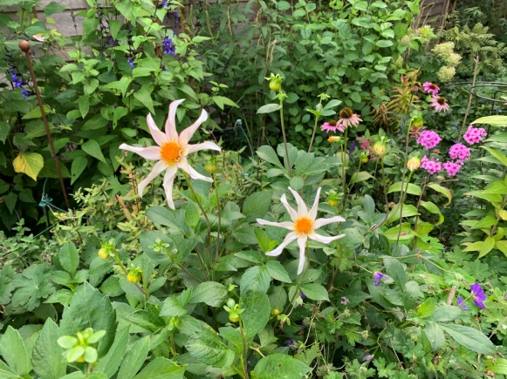
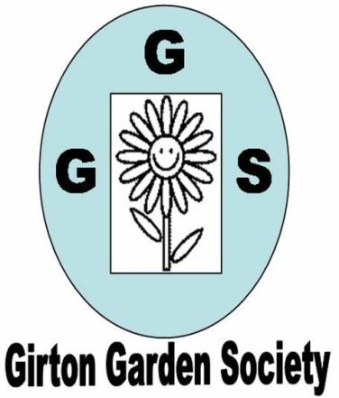
AUTUMN NEWSLETTER 2020

Dear Member, Dahlia ‘Honka fragile’ – an autumn beauty
What a strange year to say the very least. I wish I had some good news to bring you but the Government’s announcement last week of the ‘Rule of 6’, although not precluding our meetings at WCCC, does make the rigorous safety requirements very difficult to deal with. As only 12 members felt happy about meeting inside at present we feel we must suspend our autumn programme and move those speakers to the same months in 2021.
We will work out how to hold the AGM, probably by sending out the paperwork by email or post and will contact everyone again in January to update you on what is happening.
Next year
As things stand we will meet again at WCCC on Wednesday March 10th 2021 at 7.30pm to hear Joe Sharman from Monksilver Nursery in Cottenham speak on Herbaceous Perennials and the rest of the programme will then be what we missed this year - if we have returned to any semblance of normality by then. New programmes will be printed when we have some assurance that we can meet again.
We will carry your membership over to next year so you won’t need to pay again until winter 2021.
The summer trips to Wisley, Marks Hall Gardens and Arboretum and Sylvia Newman’s gardens will all be rescheduled for 2021 if possible.
Positives
With no trips to write about and no Feast Week is there anything positive to write about the last few months? Well, I think, as gardeners, we have all enjoyed the extra time in the garden and have appreciated the sounds of nature more without the constant background noise. Listening to buzzards circling overhead or large bumble bees foraging in the border have been a joy as has capturing footage of my nightly hedgehog visitor on camera. Oakington Garden Centre and Peter Graves have both done a sterling job in keeping us supplied with plants and garden items throughout the lockdown and beyond. Our own socially distanced plant sale also worked remarkably well.
On that note Corinna has masses of Spring Snowflakes bulbs (like very tall snowdrops but they flower later) available at 6 for £1, ideal for naturalising in long grass but equally good in pots. If you would like some please contact her on Cambridge 277381 or girtongardensociety@outlook.com. She also has back copies of ‘The Garden’ – the RHS magazine and other Gardening magazines. I also have back copies of ‘The Garden’ and ‘Gardener’s World’ so give either of us a ring if you would like some reading material.
If anyone bought a canna lily in the plant sale I hope they look like this now!
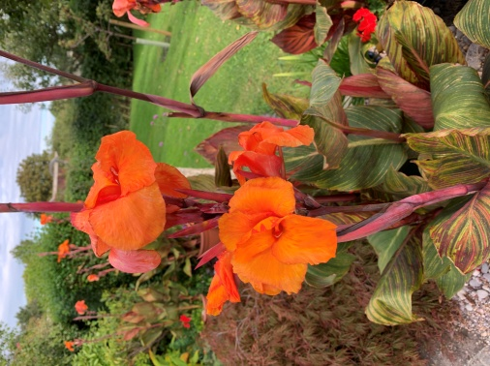
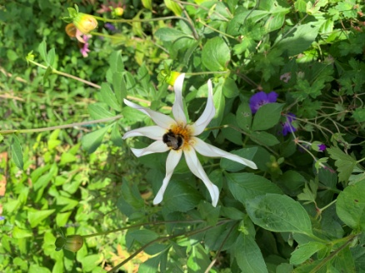
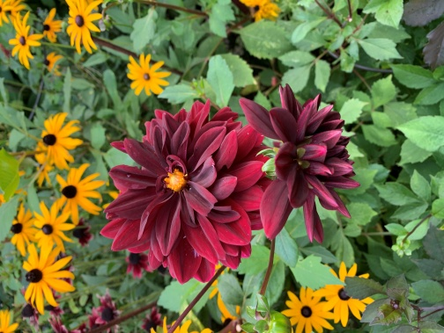

Dahlias and rudbeckias are really reliable for autumn colour and bees
There is still plenty to see at our local National Trust properties and the Botanic Gardens. Booking tickets is very easy online or by phone. Madingley Hall gardens are also open (no booking needed) and there is a cafe on the terrace with wonderful views. Alternatively ring another member and arrange to visit their garden for a garden chat before it gets too cold!
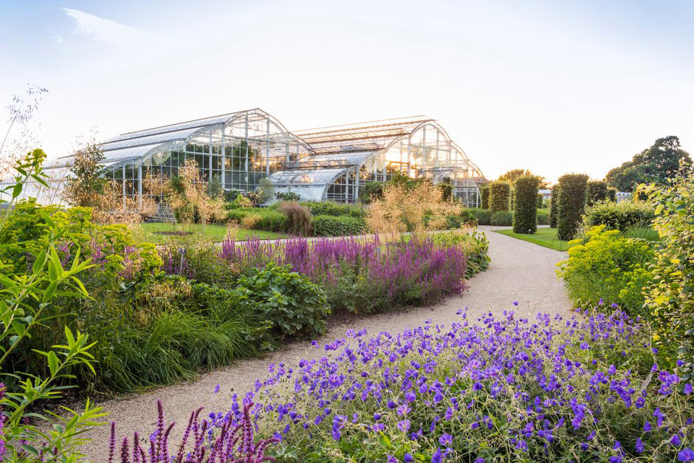
RHS Wisley in summer. Let’s hope we will be able to visit next year.

With very best wishes from us all, stay safe and well.
Kay Green, Chris Pittock, Corinna Tabor, Felicia Moor and Ruth Reynolds Contact us at girtongardensociety@outlook.com or phone Kay on 01223 276819

