 | MARCH NEWSLETTER 2020  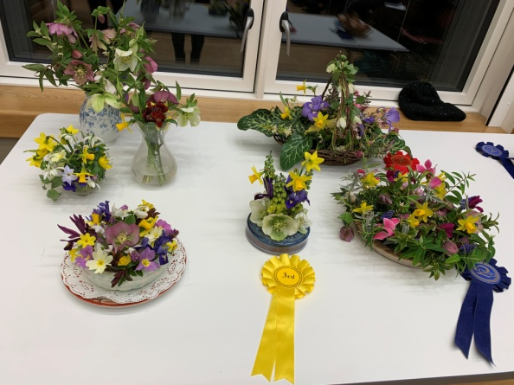  February Flower Competition table
Dear Member,
Yet again spring seems to be arriving with very little really cold weather but a great deal of rain and wind preceding it. By the time you read this snowdrops will be nearly over and the daffodils in full bloom. Some plants are excellent for scent at this time of year, sweet box(sarcococca), hamamelis, daphnes , mahonias and viburnum bodnantese to name a few. I have seen huge bumble bees sunning themselves on the house wall as early as the first week in February.
MEETINGS have been interesting and well attended since October. We have three meetings left before the summer. In March Darren Lerigo from Modern Mint will talk about how we choose to use spaces in the garden. In April Barry Gayton will talk about dealing with pests and diseases inside and out – he should know he has over 13,000 cacti and succulents in his Desert World Gardens near Brandon in Suffolk. In May Sylvia Newman, who has created many beautiful gardens in this area, will talk about creating a sensory garden. She has also agreed to show us around her own garden at Green End Farm, Longstanton on Wednesday 24th June. The AGM and social evening was very successful with over half our members attending and very positive feedback. The committee was re-elected, with Kay as chair again and Ruth Reynolds was welcomed to the committee. New members of the committee are always welcome to spread the load so do feel free to volunteer, especially if you would enjoy being involved in choosing the speakers for our talks each year.
THE PLANT SALE SATURDAY 2nd May from 2pm, 46, CAMBRIDGE ROAD, GIRTON.
This has been very successful and Janet has kindly offered to host it yet again. It is a great way to publicise the society, boost our finances (for better speakers) and offer people in the village bargain plants, seeds and surplus seedlings (tomatoes, herbs, salad seedlings and annual bedding are always very popular). It also showcases the enthusiasm for gardening in our village.
Please donate whatever you feel you can, including cakes, biscuits, jam or garden related products.
Helping: If you can help on the Plant Sale day please phone Kay on 276819 or sign the list at the next meeting. Help is needed in the morning to label, price and lay out the plants and in the afternoon to look after the plants and deal with money.
Contributions can be delivered to Janet’s house between 10am and 12noon on the day. Please make sure plants are labelled and if possible give some information on growing and flowering conditions.
SUMMER VISITS. There will be two garden visits by coach this year. Members and spouses have priority to sign up in March and the booking forms are enclosed with this newsletter; bookings open to non members in April. Posters and notices in the GPN will give prices for non members only.
VISIT WEDNESDAY 10th JUNE. We will visit the flagship RHS garden at Wisley in Surrey. There have been lots of changes since we last went so there will be many new areas to look forward to. Entry will be free for members so the only cost is the coach fare of £14.50. Non members will join GGS for £10 as this is cheaper than the entry charge. We will leave at 8.35am from the Church car park, returning around 5.50pm.Bookings will close on Wednesday 13th May.
VISIT WEDNESDAY 24th JUNE 3.00–4.30pm. A tour of Green End Farm in Longstanton with Sylvia Newman has been arranged. This is a local trip easily accessible for all our members and will cost £8 including refreshments. Lifts will be organised for those without transport and you should sign up with Chris by Sylvia’s talk in May if possible.
VISIT WEDNESDAY 15th JULY. We will go to Marks Hall Gardens and Arboretum near Colchester in Essex. Set in 200 acres of parkland there are trees from all the temperate areas of the world, two lakes, an interesting walled garden and an excellent cafe. This trip will cost members £16.25 and non members £19.25 including the coach and group entry fee. We will leave at 9.40am from the Church car park, returning around 5.00pm. Bookings will close on Wednesday 17th June.
Booking forms with full details of the venues and arrangements will be sent out with this newsletter and will also be available at the March meeting on Thursday 12th and can also be obtained from Wendy Cattell (tel.01223 277534) or by email from girtongardensociety@outlook.com. All must be returned to Wendy as hard copy with a separate cheque or cash for each visit. Early booking is advised to secure a place.
NGS GARDENS OPEN FOR CHARITY 2020 The new yellow booklet is available at Oakington Garden Centre and elsewhere. There are many wonderful gardens and groups of gardens open throughout the year and all raising money for well known charities.
GIRTON OPEN GARDENS This event is earlier than usual (better for rose growers!) on Sunday 21st June when gardens will open from 12-5pm. It is now part of an extended Girton Feast Summer Festival. If you are able to open your garden to raise money for St. Andrews Church and also to improve the flower displays around the village then please contact Mary Rodger on 01223 277316. She really would appreciate some new gardens to offer visitors. It doesn’t have to be perfect!!
GIRTON FEAST FETE. More information about this in the next letter but put the date in your diary now for Saturday 11th July. We hope to provide some late summer plants and small succulents for sale. The MINI SHOW in conjunction with the Allotment Society will be in the main marquee. There will be competitions for children, (including vegetable monsters), and adults (cut flowers and vegetables). Full details will be in the May GPN and the Feast Summer Festival programme and are already on the Events page of our website at girtongardensociety.co.uk. I hope you have found this newsletter informative and full of ideas for visits. More information will be available at our meetings and on the website. In the meantime enjoy the first taste of spring and get planting!
Kay Green and the Committee

