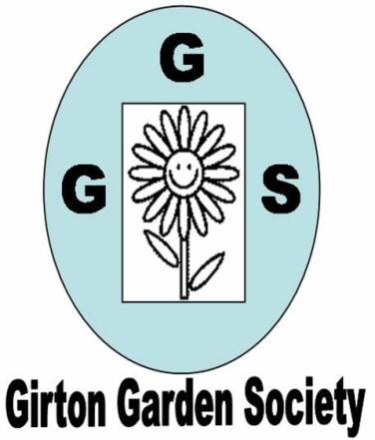 | JUNE NEWSLETTER 2020  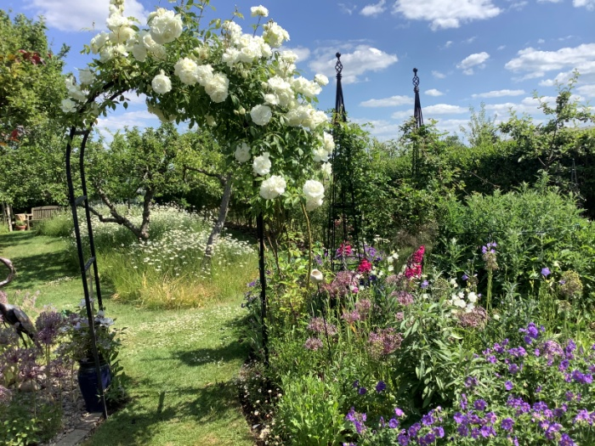
Dear Member,
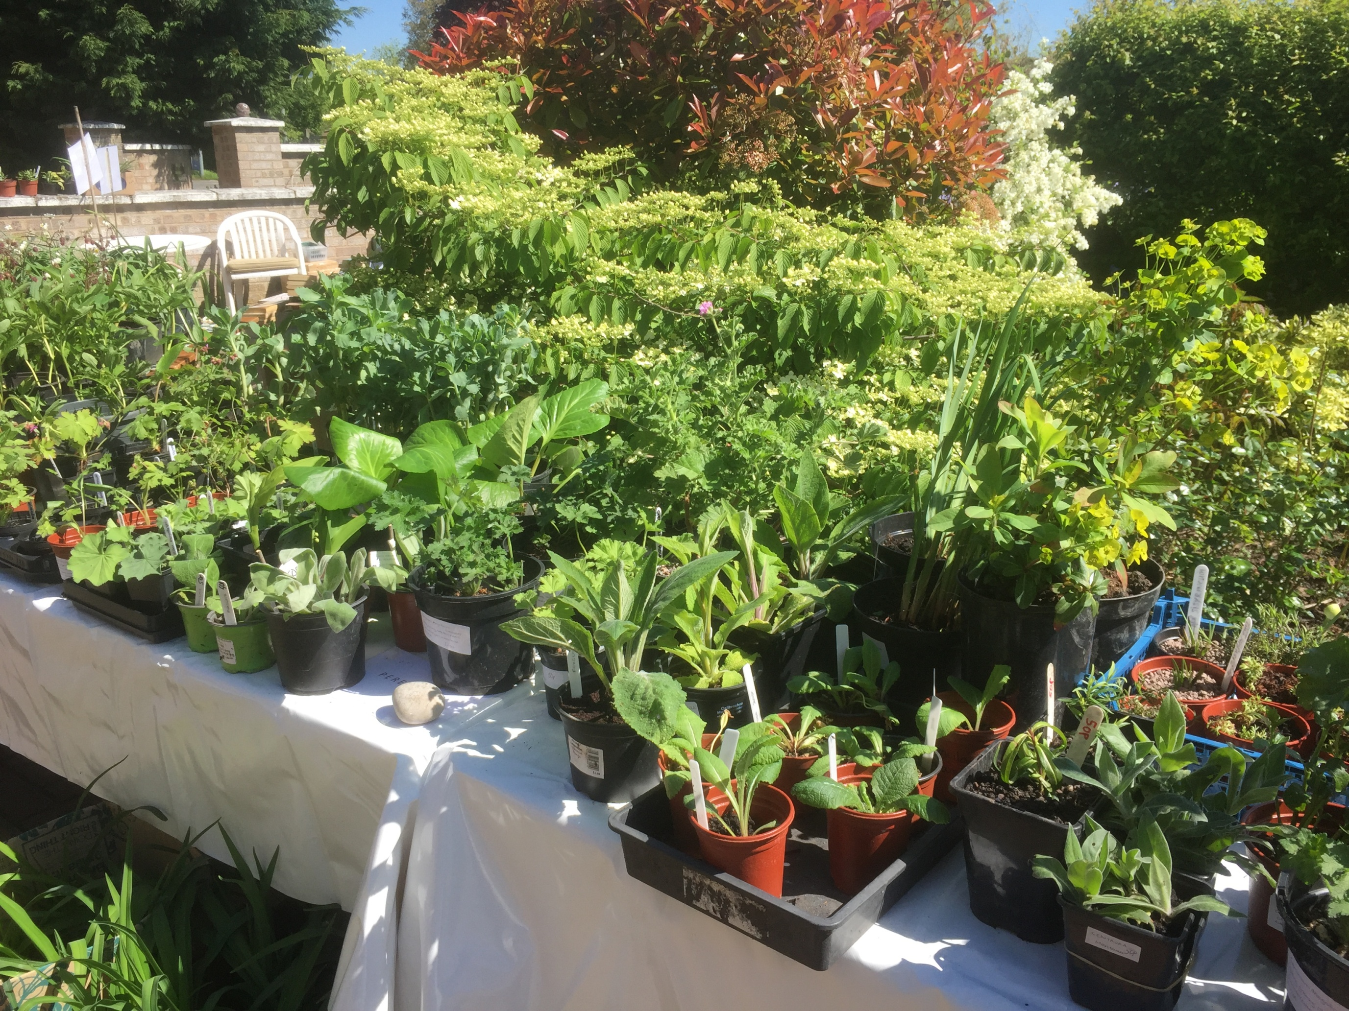
It feels very strange writing this with no idea when or even whether life will ever get back to normal or what the ‘new normal’ will be like. On the plus side most of us have been able to spend more time in our gardens and have been quite creative about sourcing plants, compost and other garden necessities. Oakington Garden Centre really rose to the challenge, delivering all over the village and to the allotments. They really deserve our support now that they are open again.
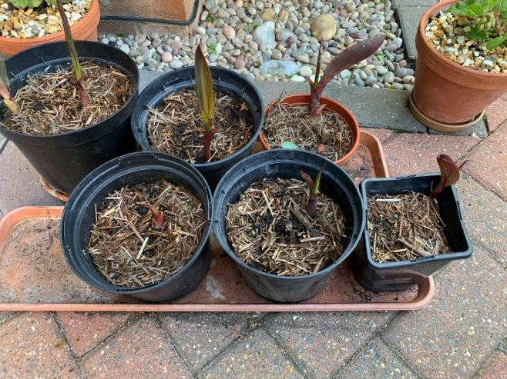
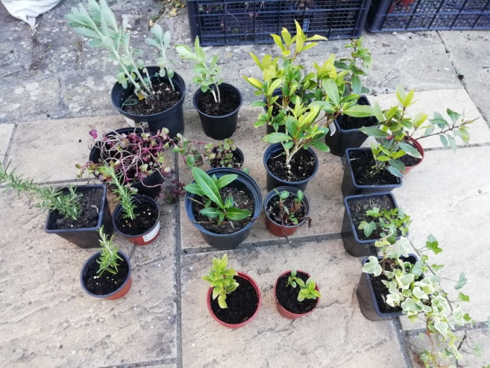
THE PLANT SALE
First of all I would like to say a big 'thank you' to everyone who contributed to making this first ever socially distanced sale work so well. The initial planning took many emails as we kept thinking of problems relating to touching items, paying and social distancing. Finally we came up with a solution that seems to have worked. People supplied photos of the plants they had grown to Corinna so that a list could be emailed out. Sellers answered their phones and left plants out on their drives for buyers to collect and, given the circumstances, it worked really well and we managed to raise a grand total of £177.60p.

Some of the plants
sold by Chris and
Kay’s cannas

DOREEN PIGGOT
As you will know Doreen celebrated her 100th Birthday in March but died soon afterwards. Many of us would have liked to attend the funeral to say goodbye to someone who had been a long standing member of the society and an inspiration to us all. It is sad that we could not be there and I hope we all raised a glass in her memory on the 17th June. A memorial service will be arranged when it is possible again.

OPEN GARDENS
There is a possibility that some of these may be open to visit in September but again it is a question of wait and see.
It is worth noting that the Botanic Gardens and many National Trust properties are now open with a booking system. I have been to Wicken Fen and Anglesey Abbey in the last week and
both were well organised, the loos were open and people were careful about keeping apart. The herbaceous borders and roses at Anglesey were lovely.
FEAST WEEK FETE AND MINI SHOW
As you will already know all the events for Feast Week have been cancelled this year. Let’s hope that next year we can have the best stall ever and many entries for the mini show.
AUTUMN PROGRAMME
At the moment our Autumn programme is still in place and the William Collyn Community Centre is due to reopen soon. There are many questions about how it will work and we are working on all the necessary safety issues. However, if all goes well we move to Wednesdays and will start again on 14th October at 7.30pm with a talk by Tim Fuller ( The Plantsman’s Preference) on ‘Naturalistic Gardening.’ The use of grasses in herbaceous borders and the influence of Piet Oudolf the influential Dutch garden designer have made this style very popular in recent years. The competition is Autumn flowers from the garden and/or a plate of 5 apples or pears (dessert or cooking). We’ll update you before October about our plans for the Autumn.

Until then, enjoy a wonderful summer of visiting friends’ gardens (we’ve all put in so much effort we need to show them to someone!) and enjoying those public spaces that remain open.
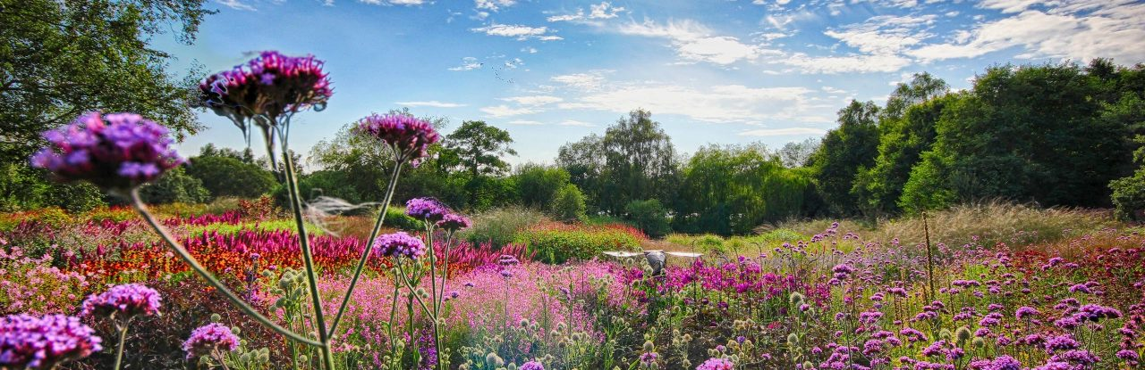

Piet Oudolf garden at Pensthorpe, Fakenham, Norfolk

All the best
Kay Green and all the committee

