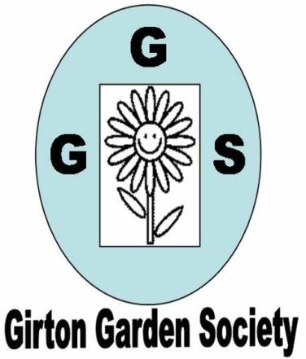 | MARCH NEWSLETTER 2019    February Competition table
Dear Member,
As I write this we are experiencing the hottest February ever. Far cry from ‘The Beast from the East’ last year. I just hope that all the burgeoning life doesn’t experience a set back with cold weather next month! The spring flowers are really stunning and scented shrubs like daphne, hamemellis and sweet box have been exceptional.
MEETINGS have been well attended since October and we have had a series of very interesting talks. We have three meetings left before the summer. This Thursday, Scott Thomson from the RSPB will show us how to encourage more birds into our gardens. In April Roger Harvey will be coming from Harvey’s Garden Plants to talk about ‘The joy of Spring Borders’. Make sure you have some money if you want to buy plants. In May Robert Brett, the curator of RHS Hyde Hall, will talk about the garden and whet our appetites for our visit in June. The AGM and social evening was very successful with over half our members attending and very positive feedback. The committee was re-elected, with Kay as chair again and Frankie Birch was welcomed to the committee. New members of the committee are always welcome to spread the load so do feel free to volunteer.
THE PLANT SALE SATURDAY 4th May from 2pm, 46, CAMBRIDGE ROAD, GIRTON.
This has been very successful and Janet has kindly offered to host it yet again. It is a great way to publicise the society, boost our finances (for better speakers) and offer people in the village bargain plants, seeds and surplus seedlings (tomatoes, herbs, salad seedlings and annual bedding are always very popular). It also showcases the enthusiasm for gardening in our village.
Please donate whatever you feel you can, including cakes, biscuits, jam or garden related products. Helping: If you can help on the Plant Sale day please phone Kay on 276819 or sign the list at the next meeting. Help is needed in the morning to label, price and lay out the plants and in the afternoon to man the stalls and deal with money. Contributions can be delivered to Janet’s house between 10am and 12noon on the day. Please make sure plants are labelled and if possible give some information on growing and flowering conditions.
SUMMER VISITS. There will be two garden visits by coach this year. They are open to Society members at a preferential cost, and also to any friends, relatives, members of Club 55 or other Girton residents for an additional charge of £3 per visit. Posters and notices in the GPN will give prices for non members only.
VISIT WEDNESDAY 5th JUNE. We will visit our local RHS garden at Hyde Hall near Chelmsford. There have been lots of changes since we last went so there will be many new areas to look forward to. The only cost for members is the coach fare which will be £12.50. We will leave at 9.30am from the Church car park, returning around 5.45pm.Bookings will close on Wednesday 1st May.
VISIT WEDNESDAY 17th JULY. We will go to the popular Bressingham Steam and Gardens, home to two world class gardens of 6 acres each plus Summer, Winter and Fragrant gardens. There is something here for every gardener to enjoy. This trip will cost members £20.25 and non members £23.25 including the group entry fee and a ride on the steam train. We will leave at 10.00am from the Church car park, returning around 5.30pm. Bookings will close on Wednesday 12th June.
Both gardens have a range of lovely features, tea rooms and plants for sale, many of which will have been seen in the gardens and raised on site. Booking forms with full details of the venues and arrangements will be sent out with this newsletter and will also be available at the March meeting on Thursday 14th and can also be obtained from Wendy Cattell (tel.01223 277534) or by email from girtongardensociety@outlook.com. All must be returned to Wendy as hard copy with a separate cheque or cash for each visit. Early booking is advised to secure a place.
VISIT THURSDAY 12TH SEPTEMBER 2.30 – 4.00pm. A tour of Wolfson College Garden with the head gardener, Phil Stigwood, has been arranged. This is a local trip easily accessible for all our members. Lifts will be arranged for those without transport. More details later.
NGS GARDENS OPEN FOR CHARITY 2016 The new yellow booklet will soon be available at Oakington Garden Centre and elsewhere. There are many wonderful gardens and groups of gardens open throughout the year and all raising money for well known charities. Always worth a visit.
GIRTON OPEN GARDENS This event kicks off Feast Week on Sunday 7th July. This year gardens will be open from 2-5pm. If you would be willing to open your garden to raise money for St. Andrews Church and also to improve the flower displays around the village then please contact Mary Rodger on 01223 277316. She really would appreciate some new gardens to offer visitors. It doesn’t have to be perfect!!
GIRTON FEAST WEEK FETE. More information about this in the next letter but put the date in your diary now for Saturday 13th July. We hope to provide some late summer plants and small succulents for sale. The MINI SHOW in conjunction with the Allotment Society will be in the main marquee. There will be competitions for children, (including vegetable monsters), and adults (cut flowers and vegetables). Full details will be in the May GPN and the Feast week programme and are already on the Events page of our website at girtongardensociety.co.uk. I hope you have found this newsletter informative and full of ideas for visits. More information will be available at our meetings and on the website. In the meantime enjoy the first taste of spring and get planting!
Kay Green and the Committee

