 | JUNE NEWSLETTER 2019  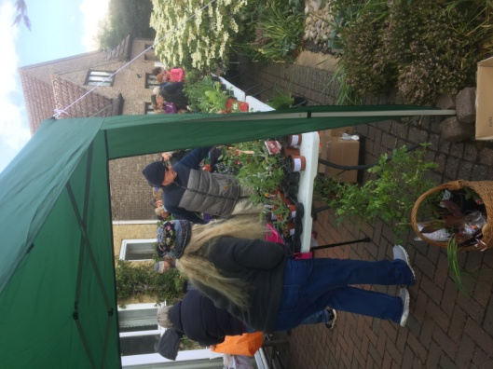  The Plant Sale
Dear Member,
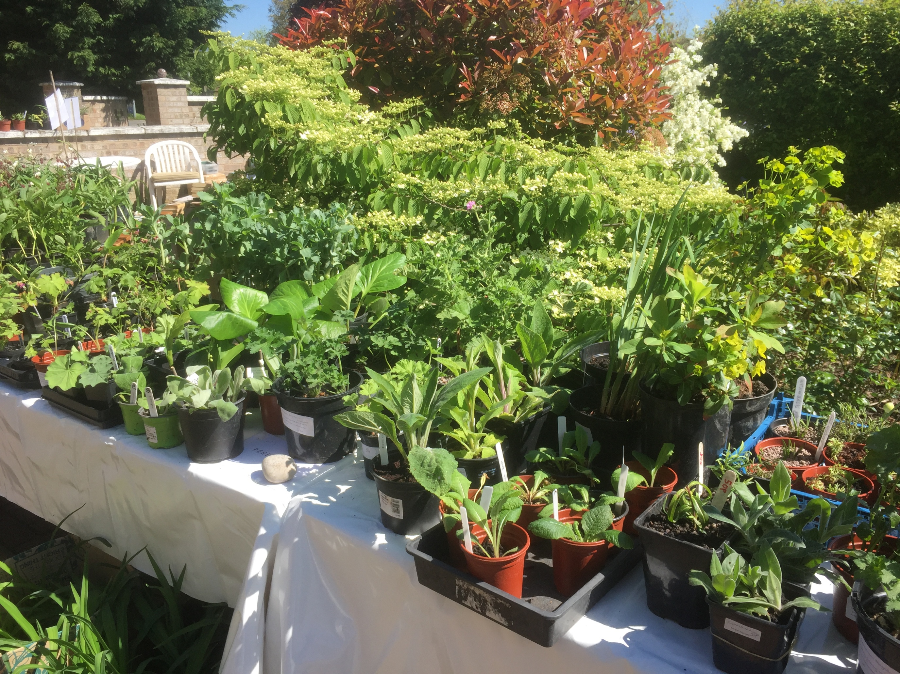
I hope you have enjoyed the Spring Programme and are looking forward to a summer of rewarding gardening. This newsletter is just a reminder of things that have already happened or are happening over the summer.
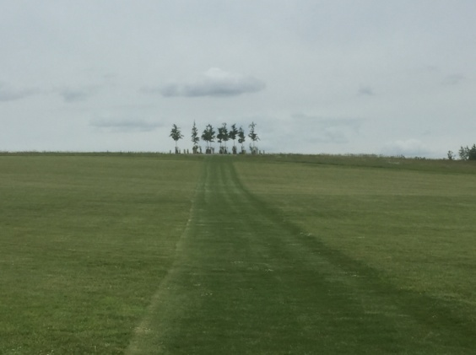
THE PLANT SALE
First of all I would like to say a big 'thank you' to everyone who contributed to making this event such a great success yet again. Despite the weather and the fact that 2 people had to hang on to the gazebo all afternoon we raised over £470 which all helps towards keeping membership fees down and the quality of speakers up. Special thanks again to Janet for allowing us to use her driveway. It certainly is an excellent location. Also thanks to all those who contributed either with their time or their wonderful plants or both! We seem to have hit on a formula that works and, although it is hard work around the event, we seem to be creating a way to share plants around the village which keeps things nicely local.
OUTINGS
RHS Hyde Hall

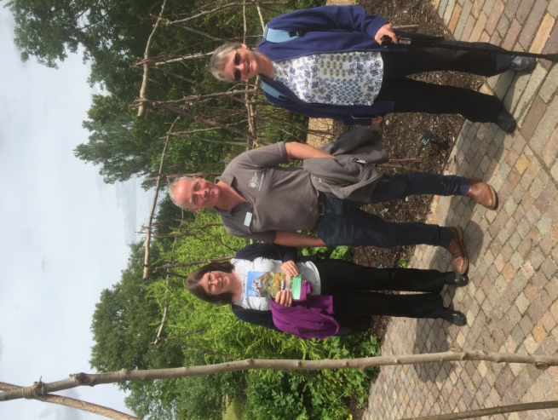

Hyde Hall
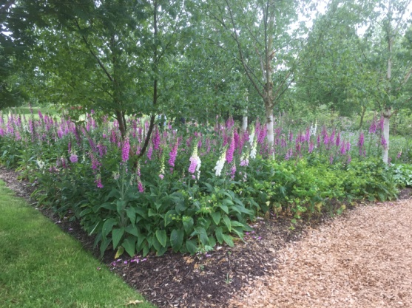

Once again we have had a very successful trip, everyone turned up on time, the coach journey was smooth, the weather was good and we saw a beautiful and inspiring garden. Our thanks must go to Wendy and Margaret for the excellent organisation which was appreciated by everyone. There was plenty to see and do plus it was clear that there is still a lot of ongoing work to landscape and plant around the hilltop restaurant and to plant up the Winter Garden. The Global Vegetable Garden was inspirational and Chris, Corinna and I were lucky enough to bump into Robert Brett the curator (our May speaker) and chat about the developments including the group of trees he planted as a focal point on the hill (see picture on previous page). Let’s hope everything goes as well for Bressingham in July.
Bressingham Steam and Gardens near Diss, Norfolk on Wednesday July 17th
We will be leaving Girton Rec promptly at 10.00am. The gardens cover 16 acres in total and include summer, winter and fragrant gardens. (www.bressingham.co.uk) This trip is fully booked and there is a waiting list. If you are unable to go please contact Wendy on 01223 277534 or e-mail us at girtongardensociety@outlook.com
Wolfson College Garden Thursday 12th September 2.30 – 4pm
A tour of this garden with the head gardener Phil Stigwood has been arranged. This is a local trip easily accessible for all our members. Lifts will be arranged for those with no transport. Tea will not be provided but we have been encouraged to take our own and use the plentiful seating around the garden if the weather is fine. If you haven’t already signed up for this please contact Chris on 01223 277182 to reserve a place and request transport if needed.
OPEN GARDENS
Sunday 7th July from 2 - 5 pm. So far 17 gardens have signed up, including the Allotment site. They will all have yellow signs outside, and are spread throughout the village. Maps will be available from the first garden you visit at a cost of £3 or using the voucher, which can be bought in advance online and covers entry to all of them. Proceeds will go to St Andrew’s church and also to improving the floral displays around the village including the telephone box. Come along and be inspired or just use it as an excuse for a good walk round the village, some excellent tea and cake and a chance to be really nosy.
FEAST WEEK FETE AND MINI SHOW
Saturday 13th July from 11am until 4pm This year we have a combined stall again with the Allotment Society at the Feast Week Fete which has the theme '50 years since the moon landing 1969’. One important reason for doing this is to raise awareness in the village as a whole about the Society and what it does. Volunteers on the day are able to talk to visitors about what we do and show them our Programme.
The fund raising part will come from donated plants and pots that we will sell. These will be available for collection towards the end of the afternoon so that we don't lose half our display by 12.30pm.
The other part will be the mini show in the marquee. The May and June editions of the Parish News had a list of all classes and they are also on our website girtongardensociety.co.uk so
I won't reproduce them here. I will just remind you that all entries need to be brought to the main marquee by 11.30am, vegetables and fruit displayed on plain white 22cm paper plates

(which are provided) and flowers displayed in colourless glass vases or jam jars. All entrants will fill in a short entry card.
Malcolm Frew (chair of the Allotment Society) has agreed to do the judging at 12 noon and rosettes will be awarded then so that all visitors to the marquee in the afternoon will be able
to view the winning entries. Winners will also be announced over the sound system later in the afternoon. So, whatever your speciality is, straight beans, funny carrots or beautiful flowers - get growing and bring something to the stall.
If you have already volunteered plants or a pot to be sold then many thanks, if you haven't but are willing to - then please give Kay a ring on 01223 276819 as she has the list. If possible these should be brought to the stall between 9 - 10.30 am so we have plenty of time to display them. Any volunteers who can help on the day, even just for an hour, particularly at 8.30am to help put up the gazebo and lay out the stall or in the afternoon to help take everything down, will be most welcome. (phone Kay or e-mail us)
AUTUMN PROGRAMME
Our autumn programme starts again on 10th October at 7.30pm at The William Collyn Community Centre, Wellbrook Way with a talk by Nigel Start on ‘Self-sufficiency from your garden.’ It is amazing how much you can grow even if you are just using windowsills or a few tubs. We hope everyone will find the venue easy to access. There is plenty of parking, it is well lit and everyone will be able to see the screen! The first small car park is for Blue Badge holders and staff but anyone who has difficulty walking can be dropped off at the main door. The other car park is just beyond the bowling green on the right.
The competition is Autumn flowers from the garden and/or a plate of 5 apples or pears (dessert or cooking).
Donations of garden related items for the raffle are always welcome.
Remember that friends and neighbours can join for just £5 for the rest of the year.
Until then, enjoy a wonderful summer of gardens through the NGS scheme yellow book. In June, King’s College Fellows Garden and Provost’s Garden is open on Sunday 30th and in July, Clare College Fellows Garden is open on Sunday 7th, Robinson daily, plus many, many more.

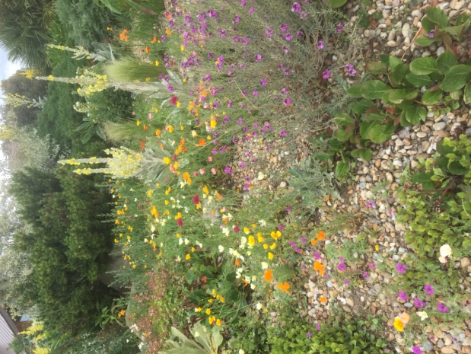
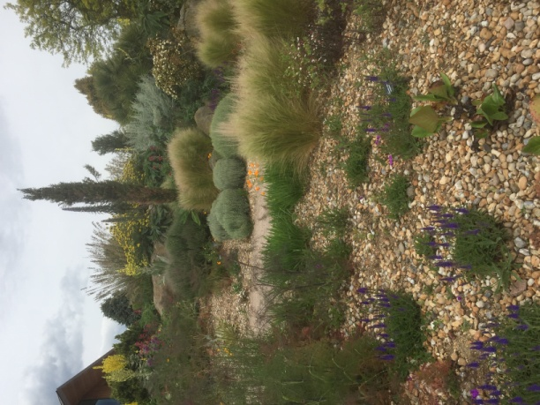

Hyde Hall
Dry Garden

All the best
Kay Green and all the committee

