 | JUNE NEWSLETTER 2018  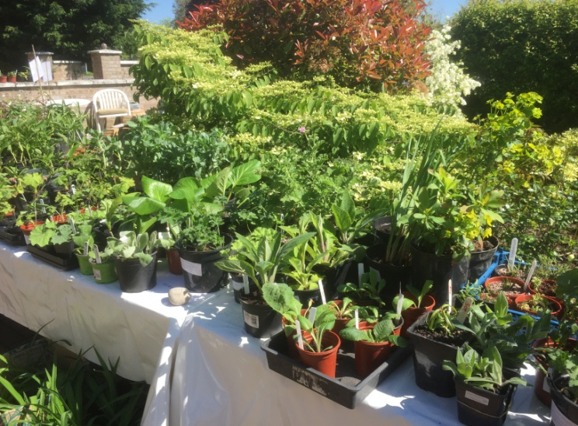  The Plant Sale
Dear Member,
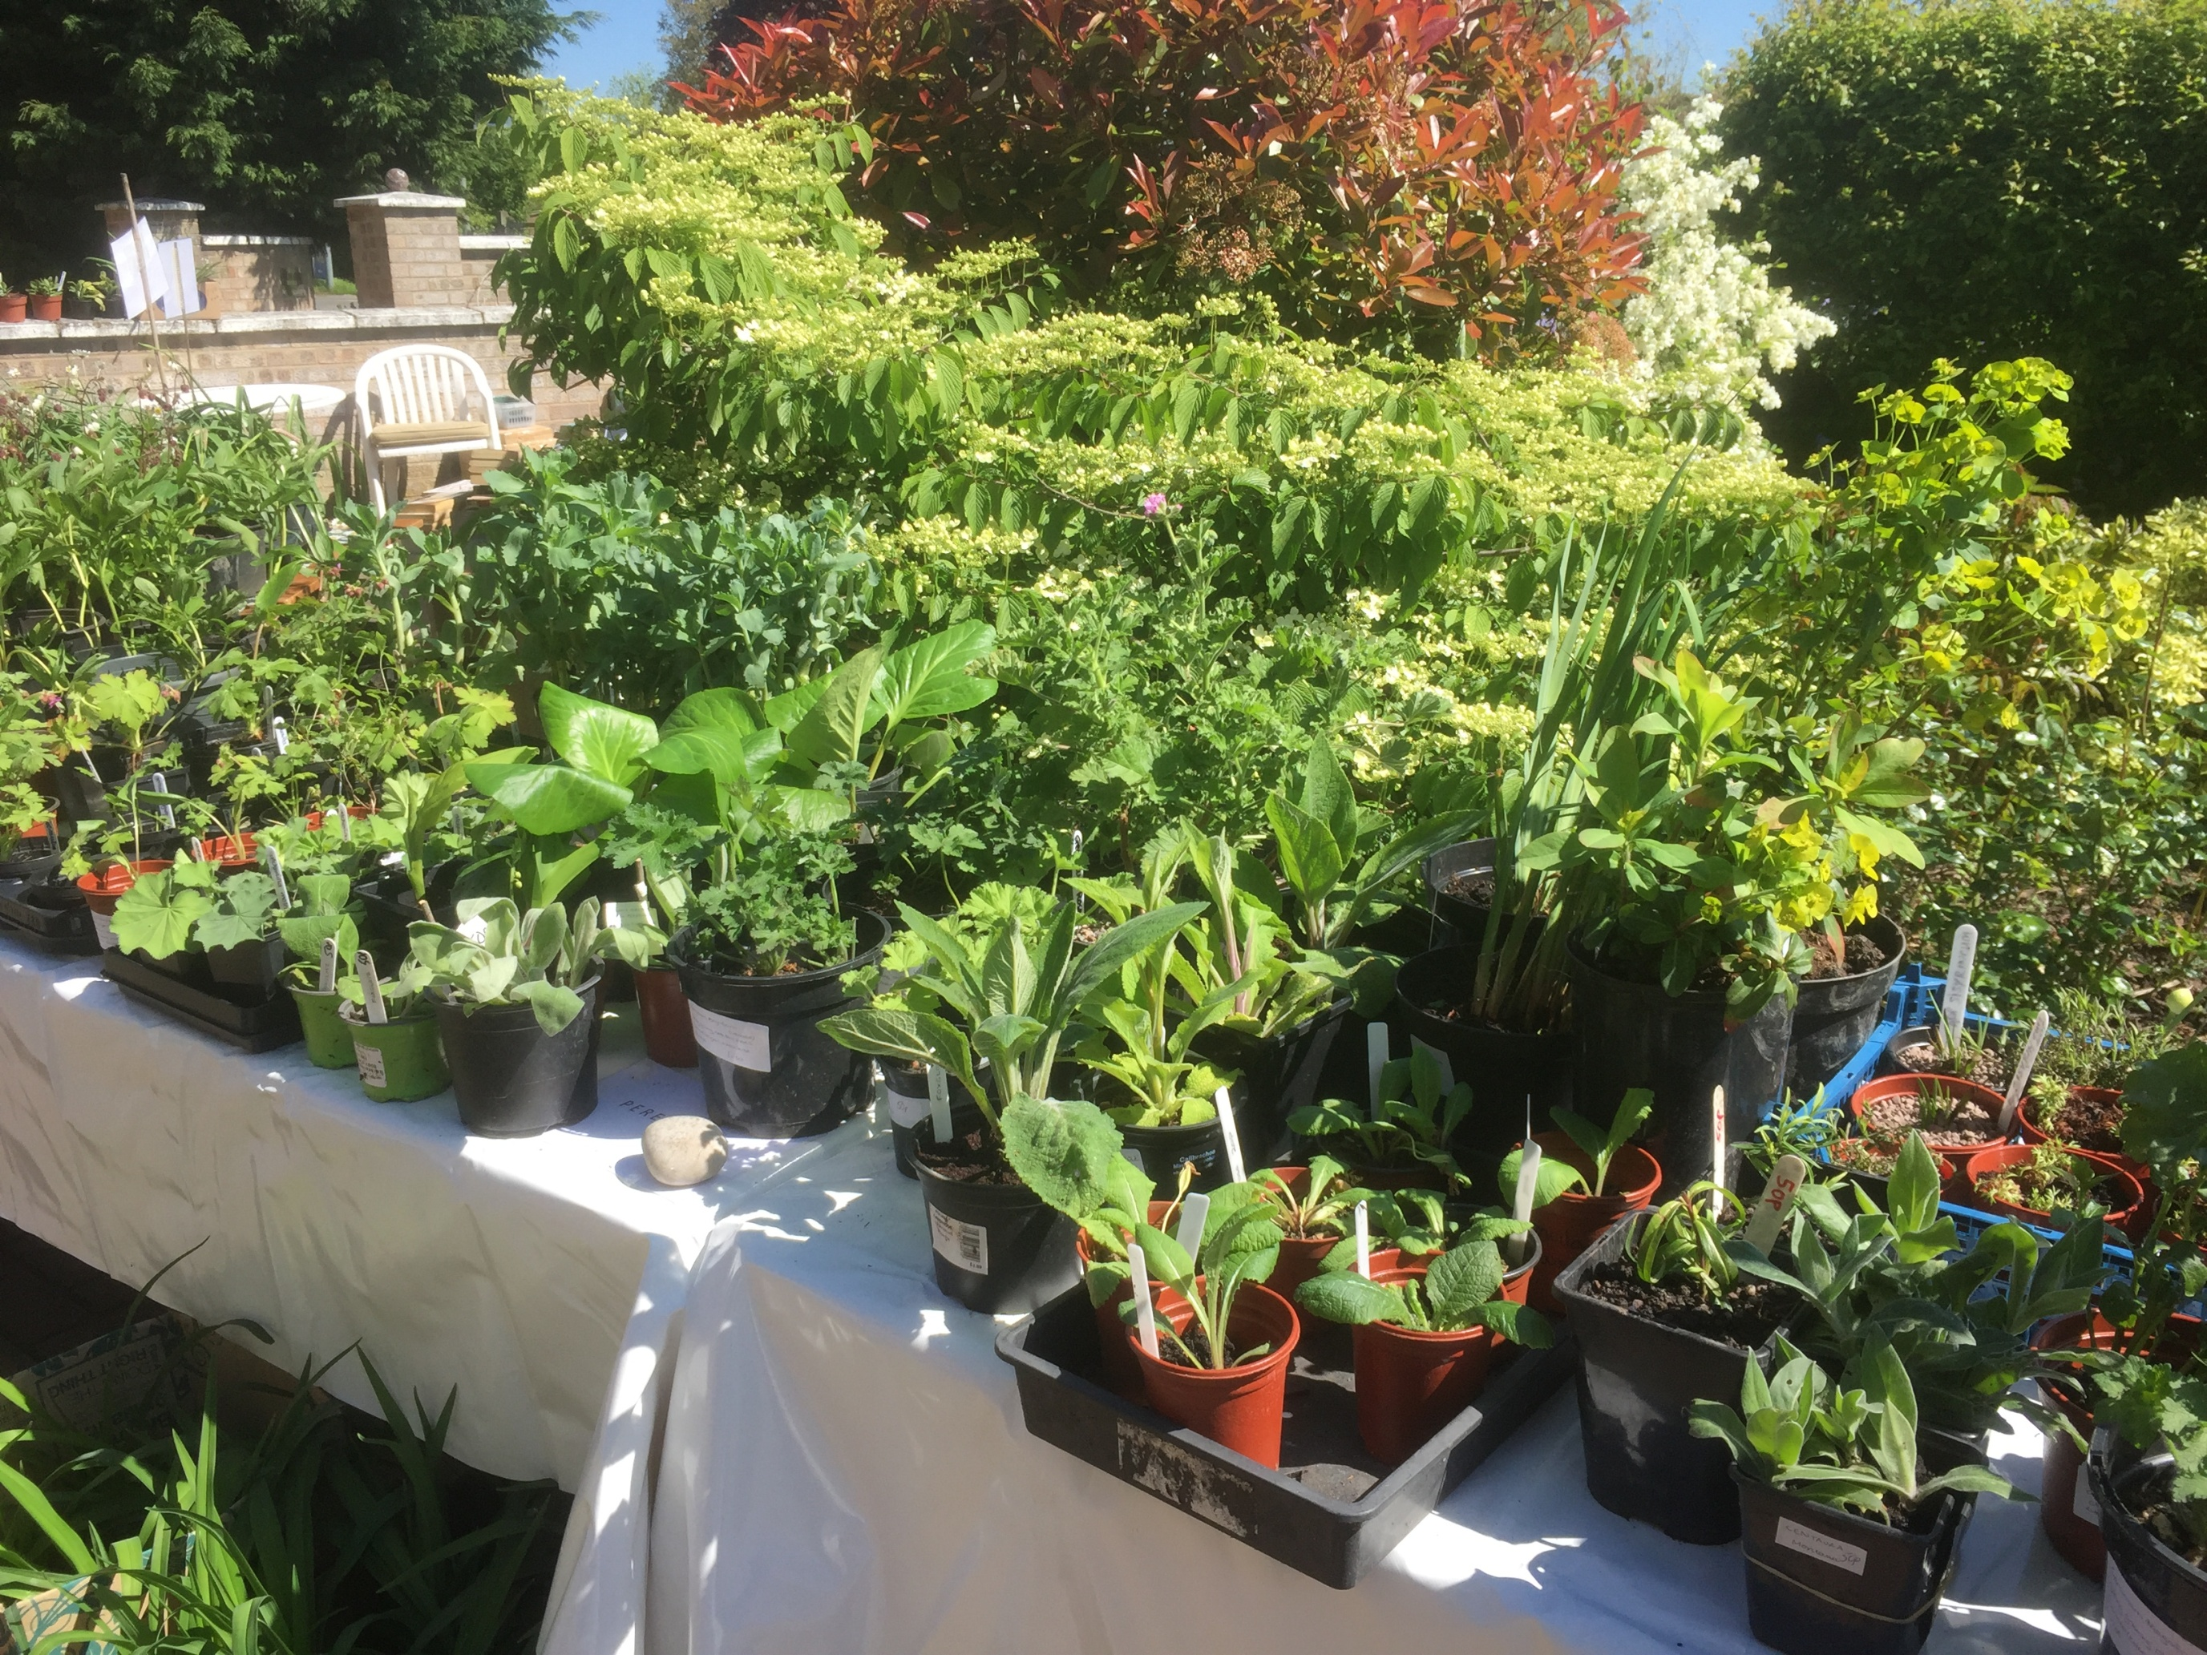
I hope you have enjoyed the Spring Programme and are looking forward to a summer of rewarding gardening. This newsletter is just a reminder of things that have already happened or are happening over the summer.
THE PLANT SALE
First of all I would like to say a big 'thank you' to everyone who contributed to making this event such a great success yet again. We raised £456.80 which all helps towards keeping membership fees down and the quality of speakers up. Special thanks again to Janet for allowing us to use her driveway. It certainly is an excellent location. Also thanks to all those who contributed either with their time or their wonderful plants or both! It really has become a much anticipated village event with people queuing with wheelbarrows for bargains. We just have to keep living up to the expectations so don’t forget that a few pots left in a corner in the autumn can become the showstoppers of the sale. Tomatoes and bedding plants are always in great demand, though this year it was a real challenge to get any ready in time.
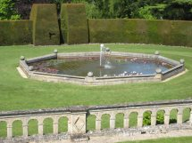
OUTINGS

Madingley Hall Gardens Tuesday 22nd May I think everyone will agree that Richard Gant provided us with a very
entertaining afternoon tour of the gardens with a lot of interesting historical detail
about the house and garden thrown in as well which helped to explain some of the detailed development. Despite the cold

wind, it was all very enjoyable, including
the tea and cake. Thanks to Chris for organising it so well.

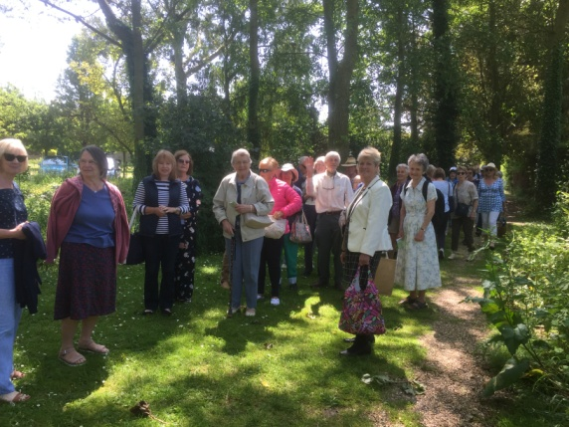
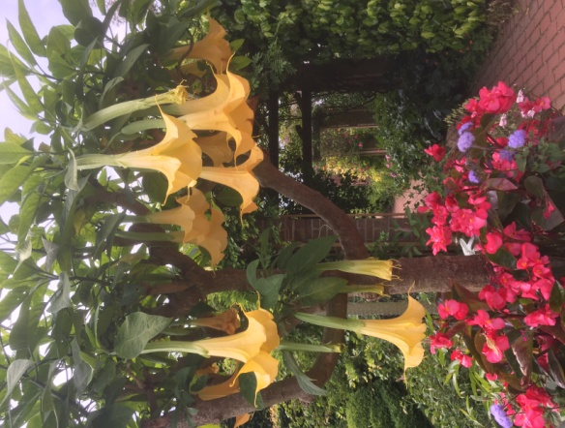
East Ruston Old Vicarage Gardens I am sure everyone who went on this trip will agree that it was a great day out. The journey was smooth in both directions, the weather was fine and the garden was a delight, packed full of rare and exotic plants in some really interesting combinations. Each of the different ‘garden rooms’ had a unique character. It was a source of inspiration for everyone.
Many thanks to Janet for her excellent organisation.
< The group arriving

A magnificent datura >

Helmingham Hall Gardens, Stowmarket on Wednesday July 18th leaving Girton Rec promptly at 10.00am.The Hall, completed in 1510, is surrounded by a deep moat, serene gardens and a deer park. This trip is fully booked and there is a waiting list. If you are unable to go please contact Janet on 01223 276393 or e-mail us at girtongardensociety@outlook.com
Janet has, sadly, decided to stand down from the committee so we will be looking for someone to take over this specific job of organising the summer outings. If anyone feels that they would be able to take this on we would love to hear from you and will give you all the support you need. Phone numbers and e-mail are on the back of your membership programme.
OPEN GARDENS
Sunday 8th July from 2 - 5 pm. So far 13 gardens have signed up, including the Allotment site. They will all have yellow signs outside, and are spread throughout the village. Maps will be available from the first garden you visit at a cost of £3 which covers entry to all of them. Proceeds will go to St Andrew’s church and also to improving the floral displays around the village. Come along and be inspired or just use it as an excuse for a good walk round the village, some excellent tea and cake and a chance to be really nosy.
FEAST WEEK
Saturday 14th July from 11am until 4pm This year we have a combined stall again with the Allotment Society at the Feast Week Fete which has the theme 'Pirates!’. One important reason for doing this is to raise awareness in the village as a whole about the Society and what it does. Volunteers on the day are able to talk to visitors about what we do and show them our Programme.
The fund raising part will come from donated baskets and tubs and some herbs and plants that we will sell. These will be available for collection towards the end of the afternoon so

that we don't lose half our display by 12.30pm.
The other part will be the mini competition in the marquee. The June edition of the Parish News had a list of all classes on page 15 and they are also on our website girtongardensociety.co.uk so I won't reproduce them here. I will just remind you that all entries need to be brought to the main marquee by 11.30am, vegetables and fruit displayed on plain white 22cm paper plates (which can be provided at the tables) and flowers displayed in colourless glass vases or jam jars. All entrants will fill in a short entry card.
Peter Seaber has agreed to do the judging at 12 noon and rosettes will be awarded then so that all visitors to the marquee in the afternoon will be able to see the winning entries. These will also be announced over the sound system later in the afternoon. So, whatever your speciality is, straight beans, funny carrots or beautiful flowers - get growing and bring something to the stall.
If you have already volunteered a basket or tub to be sold then many thanks, if you haven't but are willing to - then please give Kay a ring on 01223 276819 as she has the list. If possible these should be brought to the stall between 9 - 10.30 am so we have plenty of time to display them. Any volunteers who can help on the day, even just for an hour, particularly at 8.30am to help put up the gazebo and lay out the stall, will be most welcome. (phone Kay 01223 276819 or e-mail us)
The Cambridge Food, Garden and Produce Festival 2018.
This is in its 9th year and takes place on Parker’s Piece over the weekend 15th and 16th September. There is a large show and competition for which we have received a copy of the schedule and entry form for the show classes including fruit, vegetables, jams and chutneys, baking, cut flowers and craft. If anyone is interested then these forms are available at www.oakleighfairs.co.uk/cambridge-food-garden-produce-show or by phoning 01206 263088 or I can give you a copy. Kay 01223 276819
AUTUMN PROGRAMME
Our autumn programme starts again on 11th October with a talk by the ever popular, Rodney Tibbs on ‘You own Mediterranean Climate.’ Perhaps this is increasingly pertinent due to the effects of climate change.
The competition is 5 stems of one autumn flower and/or a plate of 5 apples or pears (dessert or cooking)
Donations of garden related items for the raffle are always welcome.
Remember that friends and neighbours can join for just £5 for the rest of the year.
Until then, enjoy a wonderful summer of gardens through the NGS scheme yellow book. In July, Clare College Fellows Garden is open on Sunday 1st, Robinson daily, King’s College Fellows Garden and Provost’s Garden on Sunday 8th plus many, many more.
All the best,
Kay Green and all the committee

