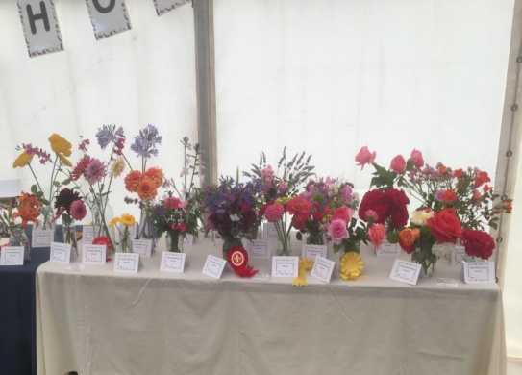
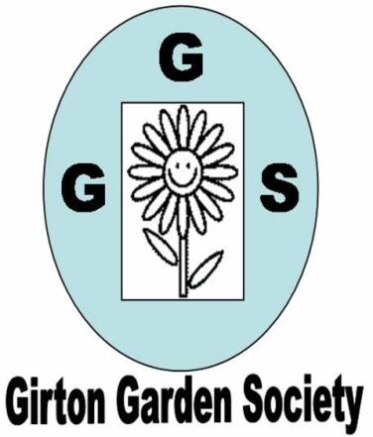
AUTUMN NEWSLETTER 2019

JULY Mini Show Entries
Dear Member,
The days are getting shorter but the lack of rain has been quite problematic in the garden and watering is still necessary to keep the early autumn display going, though that may have all changed by the time this goes out. Still autumn is coming and so is our winter programme in our new location. Lifts are being arranged if you feel it will be difficult for you to get there so please contact us if you need one.
The winter programme, William Collyn Community Centre, Wellbrook Way CB3 0GP

Thursday October 10th 7.30pm Nigel Start ‘Self-sufficiency from your garden’

Thursday November 14th 7.30pm Geoff Hodge ‘Winter colour in the garden’

Thursday December 12th 7.30pm Andrew Sankey ‘A cottager’s Christmas – the season’s customs
And traditions’
Thursday January 9th 7.30pm AGM and Social Evening

Competitions The first competition is a bunch of autumn flowers from the garden and/or a plate of apples or pears (dessert or cooking). Others are detailed on your programme. Do have a go!
Also, if you have friends, neighbours or family who might be interested in joining the Garden Society then please bring them along in October. Guests pay £2 per meeting or can join for the rest of the year up to the AGM for only £5.
Membership Thanks again to the very successful plant sale and our ‘Feast Week Fete Day’ stall our funds are healthy. Our annual membership fee is very low but the committee is very aware of rapidly rising costs for insurance, the new room hire and speakers’ expenses. At present the extra we make from the plant sale, raffles and the ‘Feast Week Stall’ do cover this but all of these activities rely on active support from members, either by way of giving up some time on the day or by donating plants. We really do appreciate all those offers of help as they help to keep the society running efficiently and spread the workload. At present our membership is around 90 but the committee is down to four. If you would be willing to help out on the committee either generally or, more specifically, to take on the Programme Secretary role we would love to hear from you. The committee only has meetings 4 times a year and we communicate regularly by e-mail. An interesting and varied programme has already been put together for 2020 and membership renewal forms will be distributed in November when we hope everyone will rejoin.
Summer events
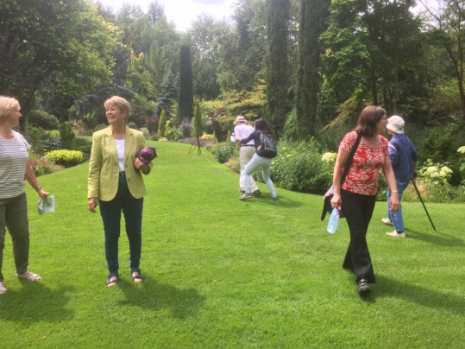
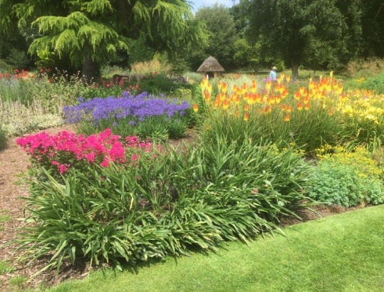
The trip to RHS Hyde Hall was covered in the last newsletter. On Wednesday July 17th we went to Bressingham Steam and Gardens near Diss. We were once again blessed with a smooth journey and good weather and the gardens were magnificent. Our thanks must go again to Wendy and Margaret who dealt with the organisation, last minute cancellations and all the many details of the planning with remarkable efficiency. Feedback has been extremely good and I think we can say ‘A good day was had by all’

Our final trip was on Thursday September 12th for a tour of Wolfson College Gardens with the head gardener Phil Stigwood. This showcased many late flowering species such as cannas, bananas, salvias and dahlias alongside some very interesting and rare trees. It is interesting to note that Wolfson, Newnham and Selwyn colleges are always accessible to visitors at any time of year. Phil encouraged us to go back regularly to see how the garden changes with the seasons. About 25 of us went on this visit which was excellently organised by Chris so many thanks for that.
Feast Week Fete Day on Saturday July 14^{th.}
The stall we shared again with the Allotment Society was very successful. Thanks must go to all members who donated plants for sale and those who helped to decorate and run the stall. We raised £128.10 from the sale of plants this year which was excellent and all helps towards the running costs of GGS. The Mini Show in the main marquee was also very successful despite the problems with the weather. Thanks are due to Malcolm Frew for judging all the entries so carefully and also to all those who submitted their flowers and vegetables. Results were published in the August GPN and there are many more pictures available to view on the website- girtongardensociety.co.uk.
Open Gardens Telephone Box
Many of you will have noticed that the phone box near the Cotton Hall is now full of flowers. This has been the brainchild of Mary Rodger who organises the very successful Open Gardens every year. It really is lovely to see the old phone boxes being restored and put to good use for the benefit of all. Sadly some plants have been stolen from it recently which has led to it being locked and protective netting put up. This is very upsetting and we ask everyone to be vigilant so that it can continue to bring joy to the residents of Girton. If you would like to help please contact Mary on 01223 277316.
We look forward to welcoming everyone back to our first meeting in October,
Kay Green, Chris Pittock, Corinna Tabor and Felicia Moor Contact us atgirtongardensociety@outlook.com or phone Kay on 01223 276819

