
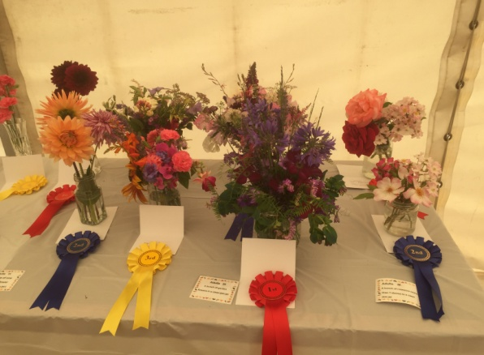
AUTUMN NEWSLETTER 2018

JULY Mini Show Entries
Dear Member,
As the summer draws to a close the strange weather continues with a really hot week followed by gale force winds bringing the apples tumbling down and knocking over top heavy pots. What will autumn and winter bring? Well, firstly a resumption of our monthly meetings as detailed below.

The winter programme, St Vincent’s Close Community Centre

Thursday October 11th 7.30pm Rodney Tibbs ‘Your own Mediterranean Climate’

Thursday November 8th 7.30pm Alan Shipp ‘A kaleidoscope of colour - hyacinths’

Thursday December 13th 7.30pm Pippa Temple ‘Where there’s a well, there’s a way – water
and gardens’
Thursday January 10th 7.30pm AGM and Social Evening

Competitions The first competition is a bunch of autumn flowers from the garden and/or a plate of apples or pears (dessert or cooking). Others are detailed on your programme. The more entries we have the better the room looks so do have a go!
Also, if you have friends, neighbours or family who might be interested in joining the Garden Society then please bring them along in October. Guests pay £2 per meeting or can join for the rest of the year up to the AGM for only £5.
Membership Thanks again to the plant sale and our ‘Feast Week Fete Day’ stall our funds are healthy. Our annual membership fee is very low and we would like to keep it low but the committee is very aware of rising costs for insurance, room hire and speakers’ expenses. At present the extra we make from the plant sale, raffles and the ‘Feast Week Stall’ do cover this but all of these activities rely on active support from members, either by way of giving up some time on the day or by donating plants. We really appreciate all those offers of help as they help to keep the society running efficiently and spread the workload.
At present our membership is around 70 but the committee will soon be down to 4 when Janet leaves. Janet has been on the committee for around 20 years and I think that her degree of commitment and dedication deserves our deepest appreciation and I am sure I speak for everyone on the committee when I say we will really miss her presence. It is difficult to ask anyone to fill Janet’s shoes but we would love to hear from you if you would be willing to help out on the committee, either generally or more specifically with organising the summer outings. We can only have the summer outings if someone is prepared to organise them but that person will have the support of the committee and all the necessary information to do this. The committee only has meetings 4 times a year and we communicate regularly by e-mail. Felicia has already put together an interesting and varied programme for 2019 and membership renewal forms will be distributed in November when we hope everyone will rejoin.
Summer events
The trips to Madingley Hall and East Ruston were covered in the last newsletter. Our final trip was to Helmingham Hall Gardens near Stowmarket on Wednesday July 18th. Again we were blessed with a smooth journey, good weather and delightful gardens. The impact of the drought was evident but the herbaceous borders, wildflower meadows and the deer park were thoroughly enjoyed by all.
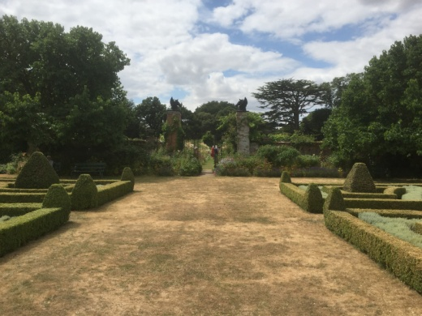
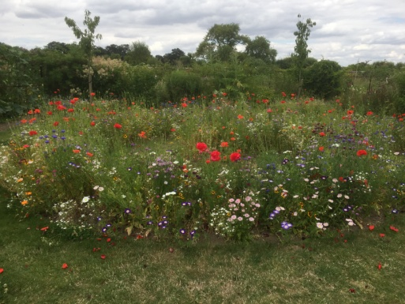

Feast Week Fete Day on Saturday July 14^{th.}
The stall we shared again with the Allotment Society was very successful. Thanks must go to all members who donated magnificent pots of flowers and plants for sale and those who helped to decorate and run the stall. We raised £120.30 from the sale of plants and tubs this year which was excellent and all helps towards the running costs of GGS. The Mini Show in the main marquee was also very successful despite the problems with the weather. Thanks are due to Peter Seaber for judging all the entries so carefully and also to all those who submitted their flowers and vegetables. Results were published in the August GPN and there are many more pictures available to view on the website- girtongardensociety.co.uk.
Open Gardens Telephone Box
Many of you will have noticed that the phone box near the Cotton Hall is now full of flowers. This has been the brainchild of Mary Rodger who organises the very successful Open Gardens every year. Money raised from Open Gardens is being used to plant seasonal containers every two months to bring life and colour to an iconic landmark in the village. A group of volunteers have cleaned and repainted it and are now responsible for planting, watering and maintenance. If anyone would like to join the group or better still volunteer to plant the containers for April (£40 per planting is available) then please either contact Kay on 01223 276819 or Mary on 01223 277316. The tubs and toughs are provided so you just need to choose some plants and pot them up. It really is lovely to see the old phone boxes being restored and put to good use for the benefit of all rather than being vandalised.
We look forward to welcoming everyone back to our first meeting in October,
Kay Green, Chris Pittock, Corinna Tabor, Felicia Moor and Janet Sheard Contact us at girtongardensociety@outlook.com or phone Kay on 01223 276819

