 | MARCH NEWSLETTER 2017  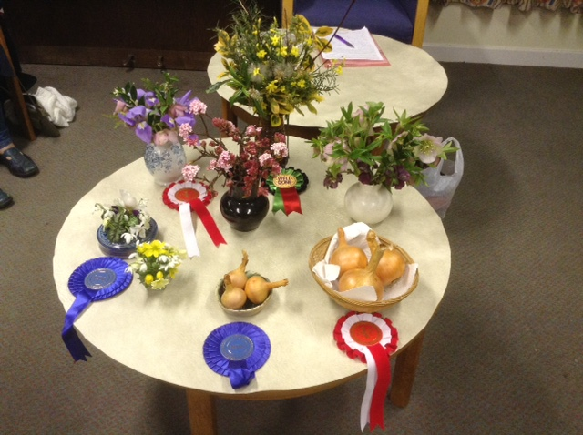  February Competition table
Dear Member,
Compared with last year spring seems to be arriving rather late but at last the daffodils are coming out and some days have felt positively spring-like. It feels right to begin sowing seeds and hoping for the kind of weather that will allow flowers and vegetables to flourish.
MEETINGS have been well attended since October and we have had a series of very interesting talks plus a challenging Garden Quiz. We have three meetings left before the summer.This Thursday, Lamorna Thomas will encourage us to produce bigger and better hanging baskets. In April Simon White will be coming from Peter Beale’s Roses and will be bringing roses. In May David White will talk about growing some unusual plants. All these sessions will have plants for sale so make sure you bring some money! We look forward to seeing you (and friends) there. The AGM and social evening was very successful with over half our members attending and very positive feedback. The committee was re-elected unchanged with Kay as chair again. We are always willing to welcome new members onto the committee to spread the load so do feel free to volunteer.
THE PLANT SALE SATURDAY 29th APRIL from 2pm, 46,CAMBRIDGE ROAD, GIRTON.
This is proving very successful and Janet has kindly offered to host it again. It is a great way to publicise the society, boost our finances (for better speakers) and offer people in the village bargain plants, seeds and surplus seedlings (tomatoes, courgettes, herbs, salad seedlings and annual bedding are always very popular). Now is a good time to split some of those perennials and sow some surplus seeds. Please donate whatever you feel you can, including cakes, biscuits, jam and other garden related products. Helping: If you can help on the Plant Sale day please phone Kay on 276819 or sign the list at the next meeting. Help is needed in the morning to label, price and lay out the plants and in the afternoon to man the stalls and deal with money. Contributions: These can be delivered to Janet’s house between 10am and 12noon on the day. Please make sure plants are labelled and if possible give some information on growing and flowering conditions.
SUMMER VISITS. Provided that we get sufficient applicants there will be two garden visits by coach this year. They are open to Society members at a preferential cost, and also to any friends, relatives, members of Club 55 or other Girton residents for an additional charge of £3 per visit.
VISIT WEDNESDAY 14th JUNE. We will visit the famous Beth Chatto Gardens at Elmstead Market near Colchester. This will cost members £18.50 and non members £21.50 which includes the group entry fee of £7.45. We anticipate a 9.15 am start from the Recreation Ground car park, returning around 6pm.Bookings will close on Friday 5th May.
VISIT WEDNESDAY 12th JULY. We will go to Coton Manor in Northamptonshire. This is a garden which always receives high ratings in surveys of popular gardens to visit. This trip will cost members £16.00 and non members £19.00 including the group entry fee of £6.00. We anticipate a 10.30am start returning around 5.30pm. Bookings will close on Monday 5th June.
Both gardens have a range of lovely features, tea rooms and plants for sale, many of which will have been seen in the gardens and raised on site. Coton Manor is quite a steeply sloping site with many steps. Booking forms with full details of the venues and arrangements will be sent out with this newsletter and will also be available at the March meeting on Thursday 9th and can also be obtained from Janet Sheard (tel.01223 276393) or by email from girtongardensociety@outlook.com. All must be returned to Janet as hard copy with a separate cheque or cash for each visit.
VISIT THURSDAY 14TH SEPTEMBER 4-6pm. A tour of Murray Edwards Garden with the head gardener, Jo Cobb. This is a local trip easily accessible for all our members. Lifts will be arranged for those without transport. More details later.
NGS GARDENS OPEN FOR CHARITY 2016 The new yellow booklet will soon be available at Oakington Garden Centre and elsewhere. There are many wonderful gardens and groups of gardens open throughout the year and all raising money for well known charities. Look out for college gardens and group openings as these are often gardens on a smaller, more personal scale.
GIRTON OPEN GARDENS This event kicks off Feast Week on Sunday 2nd July. This year gardens will be open from 2-5pm. If you would be willing to open your garden to raise money for St. Andrews Church and also to improve the flower displays around the village then please contact Mary Rodger on 01223 277316. She really would appreciate some new gardens to offer visitors. It doesn’t have to be perfect!! GIRTON FEAST WEEK FETE. More information about this in the next letter but put the date in your diary now for Saturday 8th July. We hope to provide some lovely pots again, which we will sell for collection at the end of the afternoon. A very informal MINI SHOW in conjunction with the Allotment Society will take place in the main marquee. There will be competitions for children, (including vegetable monsters and flower posies), and adults (cut flowers and vegetables). Full details will be in the May GPN and the Feast week programme and are already on the Events page of our website at girtongardensociety.co.uk. I hope you have found this newsletter informative and full of ideas for visits. More information will be available at our meetings and on the website. In the meantime enjoy the first taste of spring and get planting!
Kay Green and the Committee

