 | JUNE NEWSLETTER 2016  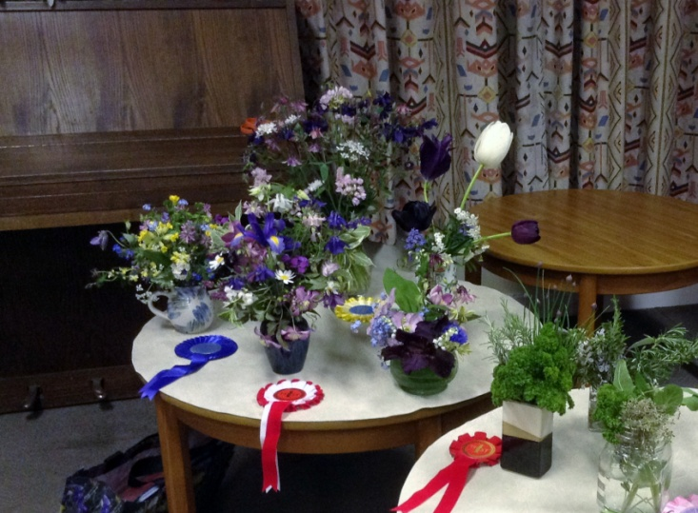  May Competition Table

Dear Member,
I hope you have enjoyed the Spring Programme and are looking forward to a summer of rewarding gardening. This newsletter is just a reminder of things that are happening over the summer.
THE PLANT SALE
First of all I would like to say a big 'thank you' to everyone who contributed to making this event such a great success again. We raised over £360 which all helps towards keeping membership fees down and the quality of speakers up. Special thanks to Janet for allowing us to use her driveway. It certainly is an excellent location. Also thanks to everyone who contributed either with their time or their wonderful plants or both! You know who you are so I won't list all the names in case I commit the unforgivable sin of forgetting someone! As I said at the last meeting it is never too early to think about next year, especially when dividing and splitting plants that have outgrown their allotted space. A few pots left in a corner in the autumn can become the showstoppers of the sale and surplus annuals sown in early spring are always popular. Tomatoes and bedding plants were in great demand.
OUTINGS (All must be pre booked with the contacts below)
RHS Wisley I am sure everyone who has signed up for the visit to RHS Wisley is looking forward to the day. All the arrangements are in hand and the coach is nearly full so let's hope for some good weather and a great day out. See you all at 8.30am on Wednesday 8th June at the Rec car park. Any problems or queries, phone Janet on 01223 276393 or e-mail us at girtongardensociety@outlook.com
Fitzwilliam College Gardens
Chris Pittock has all the details for this trip on Thursday June 30th at 6pm with the head gardener Steve Kidger. Phone her on 01223 277182 or e-mail as above if you need a lift down to the entrance or if you haven’t yet signed up or paid.
Easton Walled Garden near Grantham on Wednesday July13th leaving Girton Rec at 9.30am.This is a unique walled garden with over 100 varieties of sweet peas. Phone Janet on 01223 276393 to book or if you need any further information.
OPEN GARDENS
This event is taking place on Sunday 3rd July from 2 - 5 pm and to date there are about 13 gardens, including the Allotment site, to visit all round the village, all will have yellow signs outside. Maps will be available from the first garden you visit at a cost of £3 which covers entry to all of them. Proceeds will go to St Andrew’s church and also to improving the floral displays around the village. Come along and be inspired or just use it as an excuse for a good walk round the village, some excellent tea and cake and a chance to be really nosy.
FEAST WEEK
This year our combined stall with the Allotment Society at the Feast Week Fete on Saturday 9th July from 11am until 4pm has the theme 'School Days’. One important reason for doing this is to raise awareness in the village as a whole about the GGS and what it does. Volunteers on the day are able to talk to visitors about what we do and show them our Programme.
The fund raising part will come from donated baskets and tubs and some herbs and plants that we will sell. These will be ready for collection towards the end of the afternoon so that we don't lose half our display by 12.30.
The other part will be the mini competition. The April Parish News had a list of all classes and they are on our website girtongardensociety.co.uk so I won't reproduce them here. I will just remind you that all entries need to be brought to the main marquee by 11.30am, vegetables and fruit displayed on plain white paper plates (which can be provided at the tables) and flowers displayed in glass or jam jars. All entrants will fill in a card with the class and variety being entered on one side and their name and telephone number on the other (hidden from view ).
Peter Seaber has agreed to do the judging at 12 noon and rosettes will be awarded then so that all visitors to the marquee in the afternoon will be able to see the award winning entries. These will also be announced over the sound system later in the afternoon.
So, whatever your speciality is, straight beans, funny carrots or beautiful flowers get growing and bring something to the stall.
If you have already volunteered a basket or tub to be sold then many thanks, if you haven't but are willing to - then give me a ring on 01223 276819 as I have the list. If possible these should be brought to the stall between 9 - 10.30 am so we have plenty of time to display them. Any volunteers to help on the day (phone or e-mail us) will be most welcome .
SUNFOWER CHALLENGE
If you have grown a sunflower don't forget to send a picture before the end of August with the approximate height to our e-mail address girtongardensociety@outlook.com and you might win a prize. The prizes have been donated and the event sponsored by Girton Town Charity. It is a lovely idea to unify the village through flowers.
AUTUMN PROGRAMME
Our autumn programme starts again on 13th October with a talk by Lamorna Thomas on ‘Indoor Flora- how to grow and care for house and conservatory plants’.
The competition is 5 stems of one autumn flower and/or a plate of 5 apples or pears (dessert or cooking)
Donations of garden related items for the raffle are always welcome.
Remember that friends and neighbours can join for just £5 for the rest of the year.
Until then, enjoy a wonderful summer of gardens, gardening and other related events.
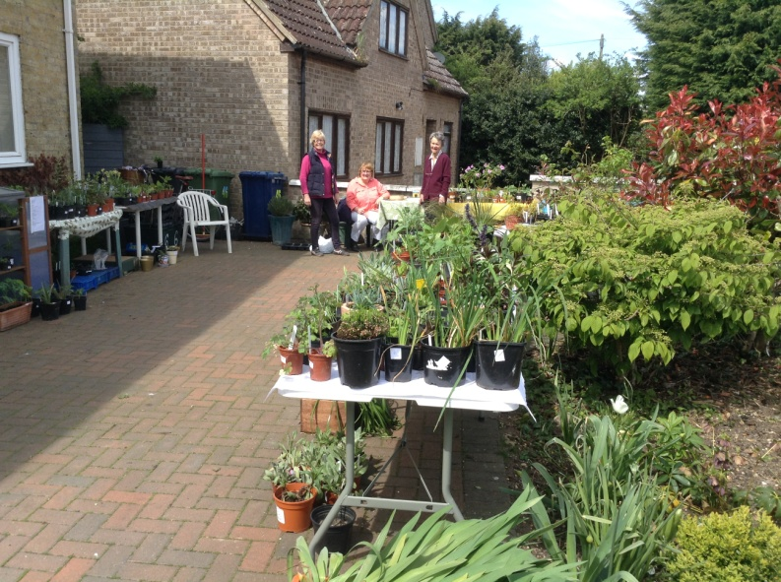

The Plant sale annuals and perennials

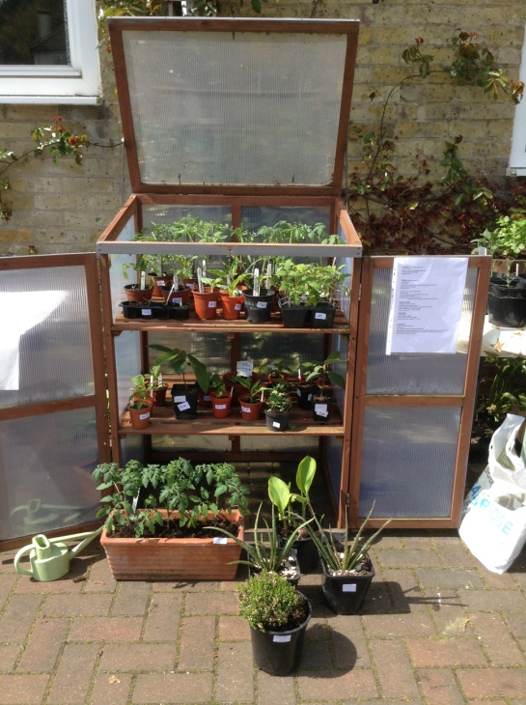

The Plant Sale Vegetables and herbs

All the best,
Kay Green and all the committee

