 | JUNE NEWSLETTER 2017    May Competition Table

Dear Member,
I hope you have enjoyed the Spring Programme and are looking forward to a summer of rewarding gardening. This newsletter is just a reminder of things that are happening over the summer.
THE PLANT SALE
First of all I would like to say a big 'thank you' to everyone who contributed to making this event such a great success again. We raised nearly £550 which all helps towards keeping membership fees down and the quality of speakers up. Special thanks again to Janet for allowing us to use her driveway. It certainly is an excellent location. Also thanks to everyone who contributed either with their time or their wonderful plants or both! You know who you are so I won't list all the names in case I commit the unforgivable sin of forgetting someone! As I said at the last meeting it is never too early to think about next year, especially when dividing and splitting plants that have outgrown their allotted space. A few pots left in a corner in the autumn can become the showstoppers of the sale. This year the peonies were all bought by someone who brought a wheelbarrow! Tomatoes and bedding plants were also in great demand.
OUTINGS (All must be pre booked with the contacts below)
Beth Chatto’s Garden I am sure everyone who has signed up for the visit here is looking forward to the day. All the arrangements are in hand and the coach is completely full so let's hope for some good weather and a great day out. See you all on Wednesday 14th June at the Rec car park for a prompt 9.15am departure. Any queries, phone Janet on 01223 276393 or e-mail us at girtongardensociety@outlook.com
Coton Manor, Coton, Northamptonshire on Wednesday July 12th leaving Girton Rec promptly at 10.30am.This is a beautiful 10 acre garden with many unusual plants, a nursery and good cafe. www.cotonmanor.co.uk There are still places available for this trip so please encourage friends and neighbours to phone Janet on 01223 276393 to book or if you need any further information.
Murray Edwards College Gardens
Chris Pittock has all the details for this trip on Thursday September 14th at 4pm with the head gardener Jo Cobb. Phone her on 01223 277182 or e-mail as above if you need a lift down to the entrance or if you haven’t yet signed up or paid. Chris will be in touch at the beginning of September with details of where we will meet.
OPEN GARDENS
This is on Sunday 2nd July from 2 - 5 pm. So far 13 gardens have signed up, including the Allotment site. They will all have yellow signs outside, and are spread throughout the village. Maps will be available from the first garden you visit at a cost of £3 which covers entry to all of them. Proceeds will go to St Andrew’s church and also to improving the floral displays around the village. Come along and be inspired or just use it as an excuse for a good walk round the village, some excellent tea and cake and a chance to be really nosy.
FEAST WEEK
This year we have a combined stall again with the Allotment Society at the Feast Week Fete on Saturday 8th July from 11am until 4pm which has the theme 'Transport/Getting Around’. One important reason for doing this is to raise awareness in the village as a whole about the Society and what it does. Volunteers on the day are able to talk to visitors about what we do and show them our Programme.
The fund raising part will come from donated baskets and tubs and some herbs and plants that we will sell. These will be ready for collection towards the end of the afternoon so that we don't lose half our display by 12.30pm.
The other part will be the mini competition in the marquee. The May edition of the Parish News had a list of all classes and they are also on our website girtongardensociety.co.uk so I won't reproduce them here. I will just remind you that all entries need to be brought to the main marquee by 11.30am, vegetables and fruit displayed on plain white paper plates (which can be provided at the tables) and flowers displayed in glass or jam jars. All entrants will fill in a short entry card.
Peter Seaber has agreed to do the judging at 12 noon and rosettes will be awarded then so that all visitors to the marquee in the afternoon will be able to see the award winning entries. These will also be announced over the sound system later in the afternoon.
So, whatever your speciality is, straight beans, funny carrots or beautiful flowers get growing and bring something to the stall.
If you have already volunteered a basket or tub to be sold then many thanks, if you haven't but are willing to - then please give Kay a ring on 01223 276819 as she has the list. If possible these should be brought to the stall between 9 - 10.30 am so we have plenty of time to display them. Any volunteers to help on the day, even just for an hour, (phone or e-mail us) will be most welcome.
AUTUMN PROGRAMME
Our autumn programme starts again on 12th October with a talk by Joanna Crosby on ‘How to cultivate apples in the modern garden.’ The talk includes a horticultural history of the apple with advice from ancient and modern gardeners. You are also encouraged to bring apples for identification.
The competition is 5 stems of one autumn flower and/or a plate of 5 apples or pears (dessert or cooking)
Donations of garden related items for the raffle are always welcome.
Remember that friends and neighbours can join for just £5 for the rest of the year.
Until then, enjoy a wonderful summer of gardens (3 in Impington, for example, including The Windmill are open in the NGS Open gardens scheme on the 24/25th June 11am – 5pm) plus plenty of gardening and other related events.
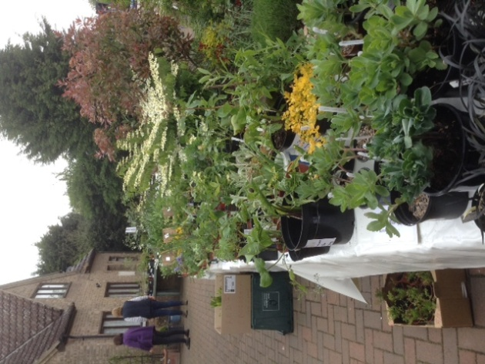
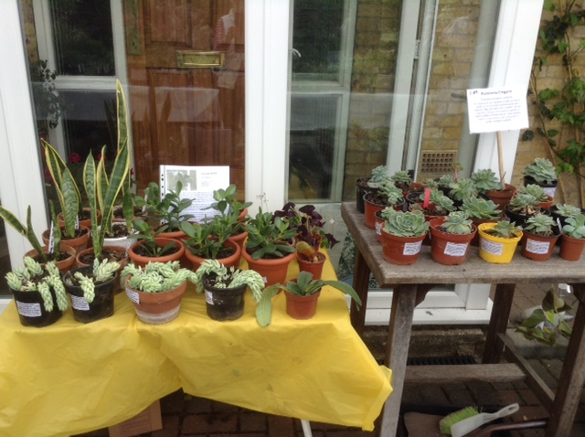
The Plant sale annuals, perennials and indoor plants

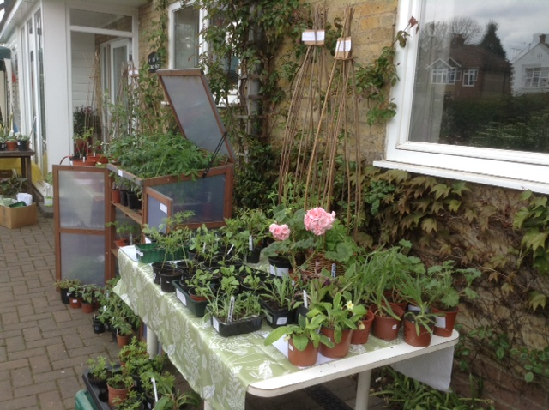
The Plant Sale Vegetables and herbs

All the best,
Kay Green and all the committee

