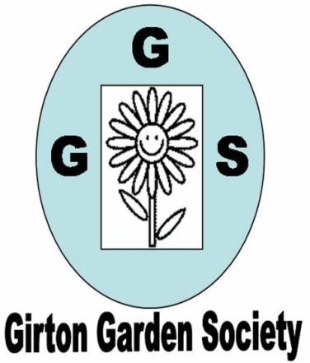  + | AUTUMN NEWSLETTER 2017  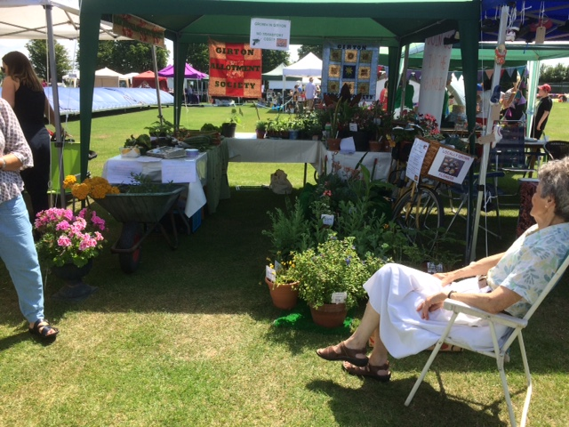  JULY Feast Week stall
Dear Member,
As our summer programme of visits comes to a close with a very successful visit to Murray Edwards College Gardens with Jo Cobb the head gardener we can look forward to our Autumn programme and some armchair gardening.

The winter programme, St Vincent’s Close Community Centre

Thursday October 12th 7.30pm Joanna Crosby ‘How to cultivate apples in the modern garden
plus a horticultural history of the apple’

Thursday November 9th 7.30pm Philip Whaite (Head gardener Wimpole) ‘Rebirth of a Garden’

Thursday December 14th 7.30pm Peter Jackson (Scotsdales) ‘Plants for winter interest’

Thursday January 11th 7.30pm AGM and Social Evening

Competitions The first competition is a bunch of autumn flowers from the garden and/or a plate of apples or pears (dessert or cooking). Others are detailed on your programme. Please have a go, the more entries there are the more cheerful and welcoming the room looks and, after all, we ARE gardeners so displaying some of our efforts shouldn’t be embarrassing!
Finally if you have friends, neighbours or family who might be interested in joining the Garden Society then please bring them along in October. Guests pay £2 per meeting or can join for the rest of the year up to the AGM for only £5.
Membership Thanks again to the plant sale and our ‘Feast Week Fete Day’ stall our funds are healthy. Our annual membership fee is very low and we would like to keep it low but the committee is very aware of rising costs for insurance, room hire and speakers’ expenses. At present the extra we make from the plant sale, raffles and the ‘Feast Week stall’ just about cover this but all of these activities really depend on the support of all members so please think about this when you are tidying the garden this autumn and pot up a few cuttings or divisions for the plant sale next year or donate a useful prize for the monthly raffle.
The committee always welcomes suggestions from all members for talks and activities that would be of interest to everyone. Felicia has already put together a really interesting and varied programme for 2018. Membership renewal forms will be distributed in November and we hope everyone will rejoin.
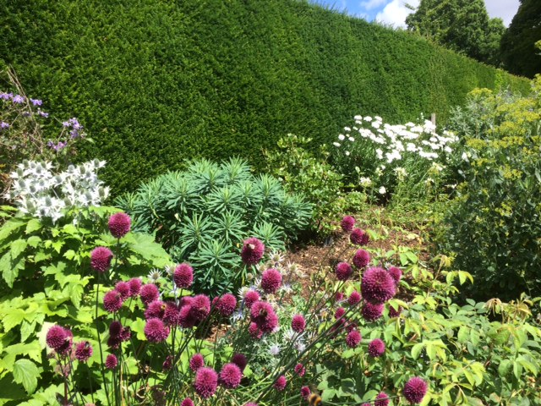
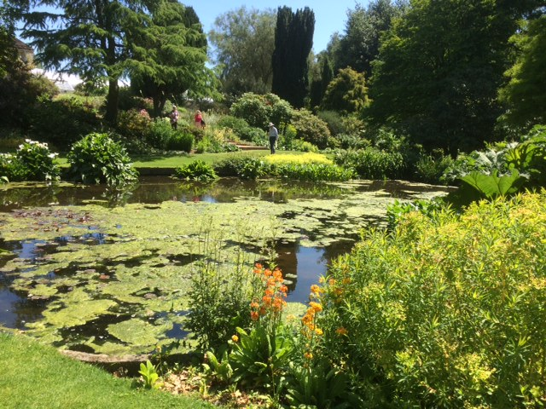
Summer events This summer we had three very successful outings to The Beth Chatto Garden in Essex, Coton Manor in Northamptonshire and Murray Edwards College Garden. Many thanks to Janet Sheard (Beth Chatto and Coton Manor) and Chris Pittock (Murray Edwards) for organising and co-ordinating these and also to Sam Clift for publicising them more widely in the village. Our trip to Beth Chatto’s Garden was very enjoyable. We had excellent weather and the sheer scale and variety of the planting had something for everyone. We had a memorable, lengthy journey to and from Coton Manor courtesy of the A14, nevertheless everyone did finally enjoy the wonderful gardens and lovely tea room. Our evening trip to Murray Edwards College with head gardener Jo Cobb was very informal and gave 23 members the opportunity to admire one of these hidden gardens with the person who had created it.

Beth Chatto Garden Coton Manor
Feast Week Fete Day on Saturday July 8^{th.} The stall we shared with the Allotment Society was very successful. Thanks must go to all members who donated magnificent pots of flowers and plants for sale and those who helped to decorate and run the stall. We raised £132.80 from the sale of plants and tubs this year which was excellent and all helps towards the running costs of GGS. The Mini Show in the main marquee was also very successful with more entries than last year. Thanks are due to Ray Gordon for judging all the entries so carefully and also to those who submitted their flowers and vegetables. Results were published in the GPN so I’ll just let the photos speak for themselves – many more available to view on the website- girtongardensociety.co.uk.
We look forward to welcoming everyone back to our first meeting in October,
Kay Green, Chris Pittock, Corinna Tabor, Felicia Moor, Janet Sheard and Marion Neville
Contact us at girtongardensociety@outlook.com or phone Kay on 01223276819
