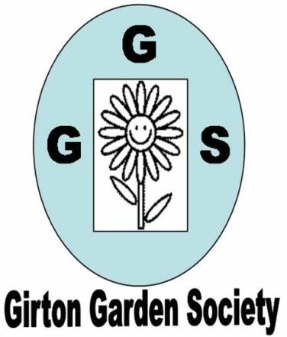  + | AUTUMN NEWSLETTER 2016  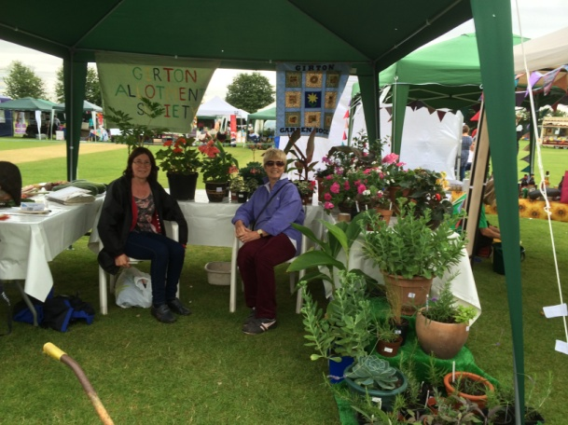  JULY Feast Week stall
Dear Member,
I hope you have had an enjoyable summer in the garden. We have had interesting weather, to say the least and the brief Indian Summer has been very welcome. I hope you are looking forward to an interesting series of meetings over the winter months.
Winter programme
at St Vincent’s Close Community Centre, Girton is as follows:

Thursday October 13th 7.30pm Lamorna Thomas ‘Indoor Flora’
(How to grow and care for house and conservatory plants)
Thursday November 10th 7.30pm Garden Quiz Night
(Come and take part in a light hearted quiz on all things horticultural. All rounds can be answered in teams)

Thursday December 8th 7.30pm Andrew Sankey ‘Six of the Best’: Chatsworth, Powis, Dorothy
Clive, Hodnet Hall, Hestercombe and Knightshayes’

Thursday January 12th 7.30pm AGM and wine and cheese social evening

Competitions The first competition is 5 stems of one autumn flower and/or a plate of apples or pears (dessert or cooking). Others are detailed on your programme. Please have a go, the more entries there are the more cheerful and welcoming the room looks and, after all, we ARE gardeners so displaying some of our efforts shouldn’t be embarrassing!
Finally if you have friends, neighbours or family who might be interested in joining the Garden Society then please bring them along in October. Guests pay £2 per meeting or can join for the rest of the year up to the AGM for only £5.
Membership Thanks again to the plant sale and our ‘Feast Week Fete Day’ stall our funds are healthy. Our annual membership fee is very low and we would like to keep it low but the committee is very aware of rising costs for insurance, room hire and speakers’ expenses. At present the extra we make from the plant sale, raffles and the ‘Feast Week stall’ just about cover this but all of these activities really depend on the support of all members so please think about this when you are tidying the garden this autumn and pot up a few cuttings or divisions for the plant sale next year or donate a useful prize for the monthly raffle.
The committee always welcomes suggestions from all members for talks and activities that would be of interest to everyone. Felicia has already put together a really interesting and varied programme for 2017. Membership renewal forms will be distributed in November and we hope everyone will rejoin.
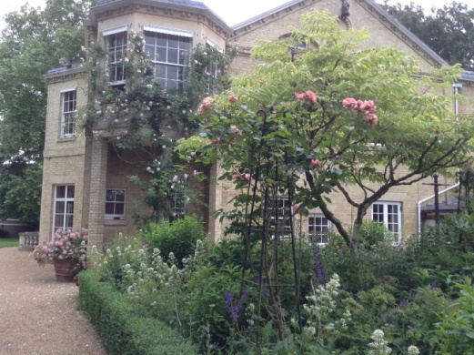
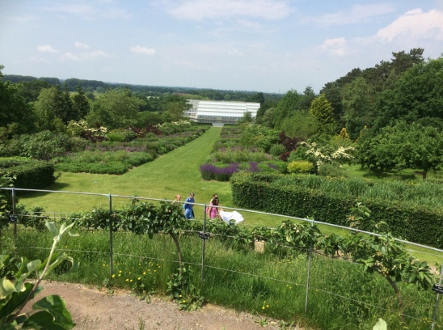
Summer events This summer we had three very successful outings to RHS Wisley, Fitzwilliam College and Easton Walled Garden. Many thanks to Janet Sheard (Wisley and Easton) and Chris Pittock (Fitzwilliam)for organising and co-ordinating these and also to Sam Clift for publicising them more widely in the village. We had wonderful weather at Wisley and everyone enjoyed the various parts of the gardens with their different planting styles. Our evening trip to Fitzwilliam College with head gardener Steve Kidger was very informal and gave everyone the opportunity to admire one of these hidden gardens. Our trip to Easton Walled Garden was an inspiration for sweet pea growers and for anyone trying to reclaim an overgrown garden.
< Wisley

Fitzwilliam >

Feast Week Fete Day on Saturday July 9th The stall we shared with the Allotment Society was very successful. Thanks must go to all members who donated magnificent pots of flowers and plants for sale and those who helped to decorate and man the stall. We managed to make £67, after the cost of buying new rosettes for the mini show had been deducted, which helps to offset the rising costs I mentioned earlier. This year we organised a Mini Show in the main marquee with the Allotment Society. This enabled more people to view the entries as there was more space. Thanks are due to Peter Seaber for judging all the entries so carefully and also to everyone who submitted their flowers and vegetables. Results were published in the GPN so I’ll just let the photos speak for themselves – many more available to view on the website- girtongardensociety.co.uk.
Sunflower Trail August brought the welcome display of cheery sunflowers around the village. This year they were even bigger. The winner, grown by Roz Curtis, was 3.63 metres tall and in joint second were Beth Cull and The Fergusson family with flowers of 3.10 metres. Well done to all who took part whether or not they submitted entries to the competition.
We look forward to welcoming everyone back to our first meeting in October,
Kay Green, Chris Pittock, Corinna Tabor, Felicia Moor, Janet Sheard and Marion Neville
Contact us at girtongardensociety@outlook.com or phone Kay on 01223276819

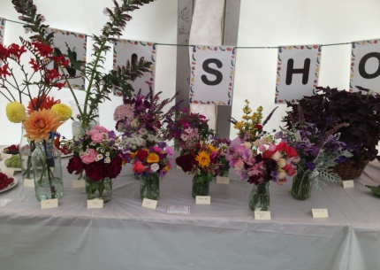
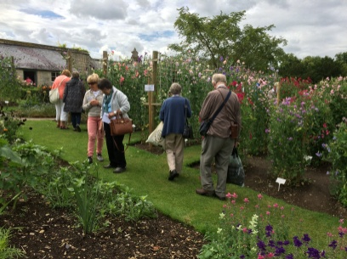
Easton Show Sunflowers

